Greiner Packaging’s Cardboard-Plastic Cup, the K3® r100 Wins
Plastic Sustainability Innovation Award

Pittston, PA, 06-18-2026. Greiner Packaging is proud to announce that its groundbreaking K3® r100 self-separating cardboard-plastic packaging has been honored with the Plastic Sustainability Innovation Award by the Plastics Industry Association. The recognition highlights the product’s contribution to improving recyclability and driving measurable progress toward a circular economy. Being already well established in Europe, this recognition highlights the product’s innovation and strategic direction as it progresses towards launching also in the United States.

K3® r100 Enables Self-Separation
K3® r100 builds on Greiner Packaging’s well established cardboard-plastic packaging concept in Europe and introduces a key development: the cardboard wrap and plastic cup are designed to separate automatically during the waste disposal process, no human intervention needed. The packaging remains fully intact during production, filling, transport, and use, but detaches once discarded without requiring any action from the consumer.
Until now, the effectiveness of cardboard-plastic cup recycling has largely depended on consumer behavior. Proper separation of the cardboard wrap and plastic component before disposal was essential to ensure that both materials entered the correct recycling streams. If not separated by the consumer, the combined packaging failed to be correctly sorted. K3® r100 eliminates this dependency on consumer action, making it a huge innovation driving the transition towards a circular economy.

It enables material separation at an early stage in the waste stream, allowing the plastic cup to be more easily identified and directed into its respective recycling process. The result is improved sorting efficiency and higher potential for quality material recovery.

“K3® r100 illustrates how innovation in packaging can contribute to broader sustainability progress,” said Jonas Kristensson, Director of Commercial Operations at Greiner Packaging. “By rethinking how materials behave at end of life, we can improve the overall effectiveness of recycling systems.”

Key Benefits of the K3® r100

K3® r100 is designed to deliver clear value for both brands and consumers. Both the plastic cup and the cardboard wrap can be made from recycled materials, helping reduce the use of virgin resources and supporting more sustainable packaging choices.
The cardboard wrap not only enhances the overall look and feel but also provides stability. This smart design enables a lighter plastic cup with thinner walls compared to standard plastic cups, reducing total plastic usage without compromising performance.
At the same time, K3® r100 offers brands more opportunities to stand out. The large printable surface, including the inside of the cardboard wrap, creates additional space for impactful branding and direct consumer communication - right at the point of use.
By combining resource efficiency, reduced material use, and enhanced communication potential, K3® r100 delivers a packaging solution that meets both, functional needs and growing expectations for sustainability.

Advancing Practical Circularity
The Plastic Sustainability Innovation Award honors companies developing solutions that are practical, scalable, and aligned with long-term circularity goals. K3® r100 stood out for its ability to improve sorting accuracy, support high-quality material recovery, and reduce environmental footprint across the product’s lifecycle. With K3® r100, Greiner Packaging further strengthens its focus on designing packaging systems that integrate seamlessly into existing waste management infrastructures while reducing dependency on consumer behavior.

The Plastic Sustainability Innovation Award reflects Greiner Packaging’s ongoing commitment to designing packaging solutions that advance recyclability and minimize environmental impact while meeting the needs of both customers and consumers.

About the Plastic Sustainability Innovation Award and PLASTICS
The Plastic Sustainability Innovation Award is an initiative of the Plastics Industry Association (PLASTICS), recognizing companies and technologies that demonstrate leadership in advancing sustainability across the plastics value chain. The award highlights innovations that improve recyclability, enable circular systems, and deliver measurable environmental benefits through practical, scalable solutions. PLASTICS represents the U.S. plastics industry, supporting innovation, sustainability, and competitiveness across the sector.

Text & images:

Text document as well as images in high-resolution quality for download:
https://greinerpackaging.canto.de/b/QBDEC

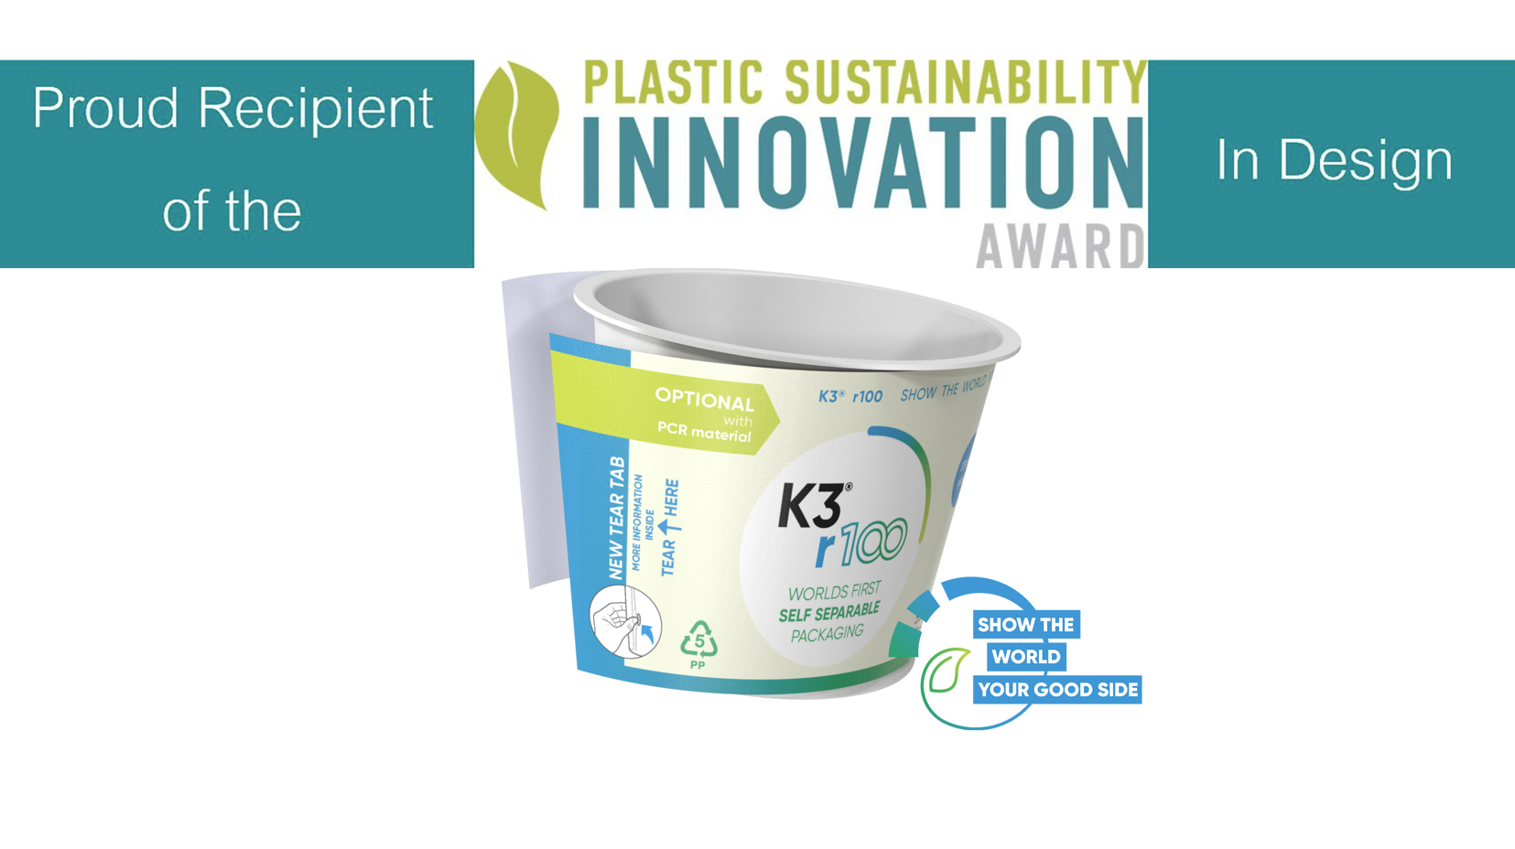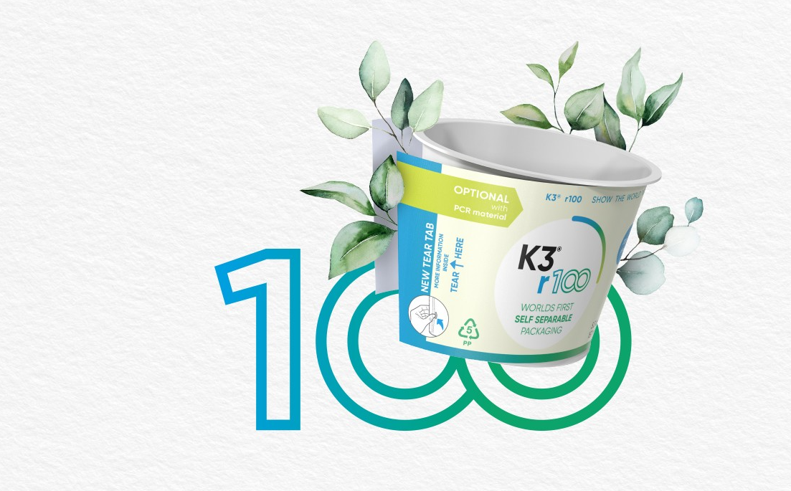

About Greiner Packaging
Greiner Packaging helps global food, beverage and household brands stand out sustainably with plastic packaging solutions that don’t compromise on quality or feel. For more than 60 years, we’ve helped customers all over the world make an impact on the shelf - and the planet - with packaging solutions born from lightweight, sustainable materials and cutting-edge European design and innovation. This is best exemplified by our award-winning K3® - a revolutionary cardboard-plastic cup. With expert design and prototyping services, a wide range of production, material and decoration technologies, and 30 locations in 15 countries, Greiner Packaging is the ideal partner for bold brands who want to show the world their good side.
To learn more about Greiner & our packaging solutions, visit greiner-gpi.com.

Greiner Packaging Media Contact:
Lisa Strasser
Global Expert Digital Marketing

Greiner Packaging International GmbH
Gewerbestraße 15, 4642 Sattledt, Austria
Mobil phone: +43 664 88238459
E-mail: l.strasser@greiner-gpi.com

