Greiner Packaging to Produce Cups with Recycled PS Content in Switzerland from 2026 in Collaboration with
Swiss Dairy Processors

Diepoldsau/Switzerland, Kremsmünster/Austria, November 18, 2025. Packaging in Switzerland is becoming even more sustainable. Starting in the first quarter of 2026, Greiner Packaging will produce K3® cups with a share of mechanically recycled polystyrene (r-PS) for the Swiss market for the first time at its Diepoldsau site. This is made possible by the installation of a new production line at the Swiss location, which allows for a significant reduction in the use of virgin PS material.
The goal is to gradually convert the entire K3® multipack range, which is commonly used for yogurt and other dairy products in Switzerland, to this more sustainable solution. This will reduce CO₂ emissions by approximately 10%* compared to previous K3® multipack cups made of polystyrene. The rollout is planned for the first half of 2026.

Joint Initiative with Strong Partners
The introduction is not happening alone. Together with Swiss dairy processors, Greiner Packaging is focusing on a market-relevant, locally anchored solution. All parties share the same goal: a more sustainable packaging future for the Swiss market. While Greiner Packaging provides the technological foundation, the manufacturers contribute their product expertise. This sends a strong message: sustainability only works together.

"With the introduction of K3® cups containing r-PS, we are setting a milestone for sustainable packaging in Switzerland. We are proud to close the polystyrene loop together with strong partners while still meeting the high standards of product safety and quality."
- Tobias Strasser, Managing Director, Greiner Packaging Switzerland

Innovation Through r-PS in the ABA Principle
The core of the film production lies in the use of mechanically recycled polystyrene from Germany in an ABA structure. This is a layered principle. The cup wall consists of three layers: outer and inner layers (A) are made of virgin material, ensuring the required product safety. The middle layer (B) consists of mechanically recycled PS, that is, polystyrene that has been collected, cleaned, shredded, and reused. This allows for a significant proportion of recycled material without compromising quality or food safety. For consumers, this means consistent quality and guaranteed product safety while simultaneously reducing the CO₂ footprint. Sustainable consumption is thus possible without any behavioral changes.
Partner companies also emphasize the sustainability aspect. Elsa Group and Emmi are pioneers in the Swiss market, working with Greiner for some time on this solution for a more environmentally friendly future.
"As a traditional Swiss company, we take responsibility and continuously make our packaging more sustainable. Our yogurt cup now contains a recycled material share, making an important contribution to promoting the circular economy."
- Marc Heim, Head of Switzerland Division, Emmi Group

Sustainable Match: K3® Cups and r-PS
The K3® is a carton-wrapped plastic cup and is already considered an environmentally friendly packaging solution. The carton layer, mostly made from recycled cardboard, significantly reduces the amount of plastic used. At the same time, it can be easily separated from the cup, allowing both materials to be disposed of and recycled separately. With the integration of r-PS, sustainability is further enhanced by reducing the use of virgin polystyrene.

"We see the introduction of r-PS in K3® cups as a great opportunity for the entire industry. By exploring new paths together, we not only contribute to climate protection but also create solutions that are easy for consumers to understand and implement."
- Matthew Robin, CEO, Elsa Group

This creates a pioneering Swiss solution that combines technological innovation, targeted use of recycled material, and close collaboration between manufacturers, retailers, and partners. It is a flagship project for more sustainable packaging in the Swiss market.
*Calculation based on average values from the Ecoinvent v3.11 database (IPCC 2021, GWP 100)
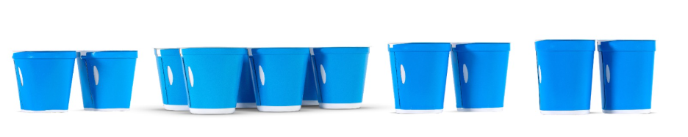
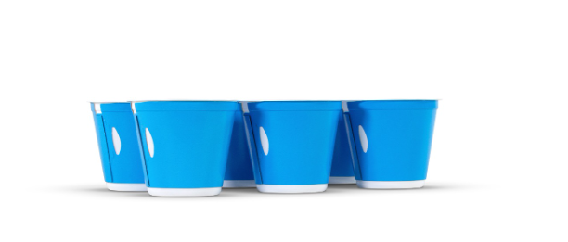
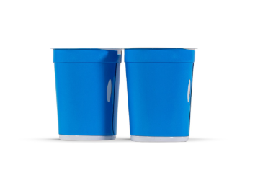
Proposed image caption: More Sustainable K3® Cups: Greiner Packaging Reduces CO₂ Footprint with r-PS Content.
Credit: © Greiner Packaging

Text & images:
Text document as well as images in high-resolution quality for download:
https://greinerpackaging.canto.de/b/QVH9G

About Greiner Packaging
Greiner Packaging is one of the leading European manufacturers of plastic packaging in the food and non-food sector. For over 60 years, the company has stood for a high level of expertise in finding solutions in development, design, production, and decoration. Greiner Packaging meets the challenges of the market with two business units: Packaging and Assistec. While the former stands for innovative packaging solutions, the latter focuses on the production of customized technical parts. Greiner Packaging employs over 4,900 people at 30 locations in 18 countries worldwide. In 2024, the company achieved an annual turnover of 875 million euros (incl. joint ventures). This is more than 40% of Greiner’s total turnover.

Greiner Packaging Media Contact:
Peter Dobosz
Global Expert PR & Content Marketing

Greiner Packaging International GmbH
Gewerbestraße 15, 4642 Sattledt, Austria
Mobile: +43 664 4110735
E-mail: p.dobosz@greiner-gpi.com

