# **Nounós and Yaza Grow Sustainably** **with Greiner Packaging**

**Nounós Creamery sees a 150% sales increase after switching to Greiner Packaging’s K3**® **cup.**

**Yaza Labneh expands from 10 to 45 states, leveraging Greiner’s sustainable packaging to support nationwide growth.**

**Greiner Packaging’s innovative K3**® **cup helps both brands enhance sustainability, boost market appeal, and improve operational efficiency.**

**Pittston, May 28, 2025. Nounós Creamery and Yaza Labneh, two leading brands in the U.S. dairy market, have successfully expanded their presence with the support of Greiner Packaging’s innovative and sustainable K3® cup. By choosing Greiner Packaging as their partner, both brands have strengthened their market position while reinforcing their commitment to sustainability.**

**Nounós Creamery: Growth Through Sustainable Innovation**

Nounós Creamery, known for its handcrafted Greek yogurt, sought to introduce a 16oz multi-serve option while maintaining its dedication to sustainability. After evaluating several options, the company selected Greiner Packaging’s K3® cup for its innovative cardboard-plastic combination, which reduces material usage and enhances recyclability.

Since making the switch, Nounós has seen a 150% increase in sales, demonstrating strong consumer preference for the new packaging.

“The move to the K3® cup has driven both top-line growth and bottom-line profitability while supporting our commitment to innovation and sustainability,” said John Belesis, Co-Founder of Nounós Creamery. “Greiner Packaging’s solution has allowed us to remain competitive while staying true to our brand values.”

**Yaza Labneh: Expanding Nationwide with Greiner’s K3® Cup**

Yaza Labneh, a brand dedicated to bringing authentic Mediterranean flavors to American consumers, has experienced rapid growth, expanding from 10 states to 45 states in just two years. A key part of this success has been the brand’s focus on sustainability, supported by its choice of the K3® cup.

“At Yaza, we believe in delivering authentic Mediterranean cuisine while upholding our responsibility to the environment,” said Karim Khalil, Founder of Yaza. “That’s why we chose Greiner’s K3® cup – it aligns seamlessly with our ethos of responsible and environmentally conscious practices.”

Greiner Packaging’s lightweight, recyclable design has provided Yaza with a solution that enhances product appeal while meeting consumer and retailer demands for sustainable packaging.

**The Benefits of Greiner Packaging’s K3® Cup**

The cardboard wrap on Greiner Packaging’s innovative K3® cardboard-plastic combination provides stability, allowing the cup to be produced with thinner walls and less material, reducing its CO2 footprint. The cup and wrap can be easily separated, which is crucial for recyclability. Additionally, as the cup is always white or transparent, it ensures high-quality recyclates that are not contaminated by inks, making it an ideal solution for sustainable packaging.

**A Commitment to Sustainable Innovation**

By collaborating with Greiner Packaging, Nounós and Yaza have not only improved their market performance but also strengthened their commitment to sustainability. The K3® cup’s innovative design has enabled both brands to expand their reach, appeal to eco-conscious consumers, and enhance operational efficiency.

“We are proud to support Nounós and Yaza in their growth journeys,” said Jonas Kristensson, Sales Director at Greiner Packaging in Pittston. “Our team worked closely with both brands to ensure their packaging met sustainability goals while also providing strong shelf appeal and functionality.”

Greiner Packaging is dedicated to providing recyclable, innovative, and sustainable packaging solutions that enable brands to “Show the world their good side.” Through its focus on these principles, Greiner Packaging helps brands grow responsibly while driving a more sustainable future.

**Text & images:**

Text document as well as images in high-resolution quality for download:

<https://greinerpackaging.canto.de/b/VOLKE>

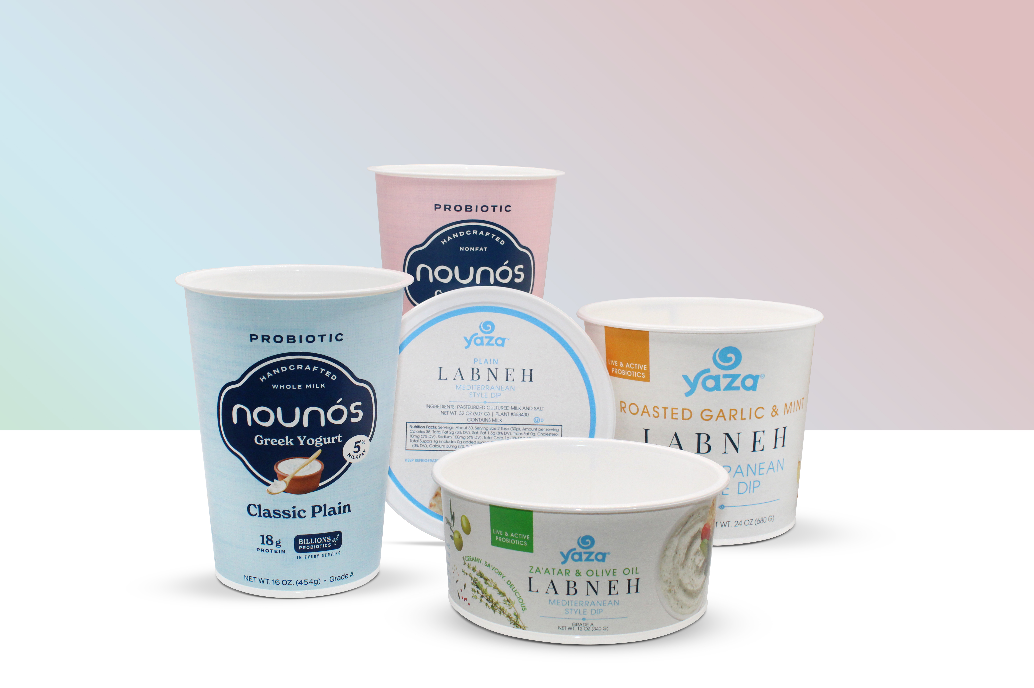**Caption:** Greiner Packaging’s eco-friendly K3® cup is fueling growth for dairy brands - boosting Nounós Creamery’s Greek yogurt sales by 150% and helping Yaza Labneh expand to 45 states.

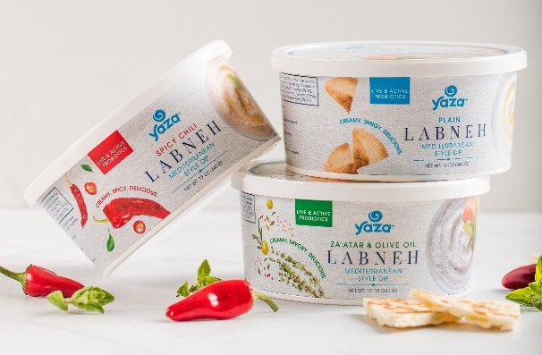Ein Bild, das Text, Geschirr, Milchprodukte, Becherdeckel enthält.

|  |
| --- |
| **About Greiner Packaging**  Greiner Packaging helps global food, beverage and household brands stand out sustainably with plastic packaging solutions that don’t compromise on quality or feel. For more than 60 years, we’ve helped customers all over the world make an impact on the shelf - and the planet - with packaging solutions born from lightweight, sustainable materials and cutting-edge European design and innovation. This is best exemplified by our award-winning K3® - a revolutionary cardboard-plastic cup. With expert design and prototyping services, a wide range of production, material and decoration technologies, and 30 locations in 18 countries, Greiner Packaging is the ideal partner for bold brands who want to show the world their good side.  **To learn more about Greiner & our packaging solutions**, visit [greiner-gpi.com](http://greiner-gpi.com/en).  **Greiner Packaging Media Contact:**  Peter Dobosz  Global Expert PR & Content Marketing  Greiner Packaging International GmbH  Gewerbestraße 15, 4642 Sattledt, Austria  Mobil phone: +43 664 4110735  E-mail: [p.dobosz@greiner-gpi.com](mailto:p.dobosz@greiner-gpi.com) |