**Orthomol opts for high-tech & r-PET**

**with tailor-made solutions from Greiner Packaging**

* Orthomol and Greiner Packaging are strengthening their partnership with an exclusively developed high-tech production line that guarantees the highest quality standards and significantly increases output
* The new state-of-the-art facility combines innovative camera systems with advanced hygiene measures, setting new industry standards
* Sustainability as a shared goal: Orthomol is using recycled PET in its vials and plans to further increase this share in the coming years

**Kremsmünster, Austria. May 13, 2025. The long-standing partnership between Orthomol, a leading supplier of dietary supplements, and packaging expert Greiner Packaging has reached a new milestone. Since early 2025, Greiner Packaging has been manufacturing Orthomol’s vials using recycled PET. A high-tech production line, developed exclusively for Orthomol, sets new standards in efficiency, quality, and sustainability, cementing the successful collaboration between the two companies.**

**A partnership shaping the future**

Since 2022, Greiner Packaging has produced Orthomol’s signature brown vials for their nutritional supplements. With the launch of a fully automated line in January 2025, both product quality and production capacity have seen substantial improvements. This exclusive line was precisely tailored to Orthomol’s needs. “With 18 cameras and an innovative laminar flow system, we guarantee that every vial meets our strict quality standards and fulfills Orthomol’s high requirements,” explains Daniel Holspach, Key Account Manager at Greiner Packaging.

**Quality down to the last detail**

The production line developed specifically for Orthomol is the only one of its kind in Europe. Equipped with a highly precise camera system, it inspects each vial in real time for geometry, color, and possible inclusions. Thanks to the combination of cutting-edge camera technology and a laminar flow system that keeps dust particles at bay, the highest hygiene standards are ensured. This investment in top-tier technology underlines Greiner Packaging’s commitment to providing customers with reliable, flawless production. It’s a testament to the company’s innovative strength and its ability to meet customer needs individually.

“The vials are one of our most popular delivery forms worldwide,” notes Dr. Jörn Weißenfeld, a member of Orthomol’s executive management responsible for production and sustainability, among other areas. “The fact that Greiner Packaging is investing with us in the sustainable further development of these vials is of great value to Orthomol.”

**Sustainability as a shared priority**

Sustainability is a central pillar of the partnership. Greiner Packaging has already taken an important step toward more sustainable production by introducing recycled PET (r-PET) for the vials. This measure helps reduce the environmental footprint and lays the foundation for further progress in the circular economy. The long-term goal is to produce the vials entirely from recycled PET to consistently pursue sustainability targets.

“Sustainability is also a top priority for Orthomol, and we’re delighted to work together on solutions that are both eco-friendly and forward-looking for the industry,” says Daniel Holspach.

**Looking ahead to the future**

The partnership between Orthomol and Greiner Packaging focuses on targeted investment in modern technology and practical solutions to improve production quality and efficiency. Greiner Packaging contributes its expertise in recycled materials to meet the growing demands for sustainability and to develop and advance packaging concepts that fulfill current and future requirements. This partnership emphasizes both innovation and responsible resource use, offering an approach that meets the demands of the packaging industry. Orthomol and Greiner Packaging are working together to drive sustainable solutions that enhance both efficiency and long-term viability.

**About Orthomol**

Based in Langenfeld, Germany, Orthomol is a pioneer of orthomolecular nutritional medicine in Germany. For over 30 years, the company has developed and marketed precisely dosed micronutrient combinations for a wide range of applications. Orthomol products are designed as dietary supplements for various life situations and are available in pharmacies. Development and production are carried out according to the international quality standard ISO 22000. Together, Greiner Packaging and Orthomol are writing a success story defined by innovation, sustainability, and trust – a partnership that is delivering success: one vial at a time”.

**Text & images:**

Text document as well as images in high-resolution quality for download:

<https://greinerpackaging.canto.de/b/M22OB>

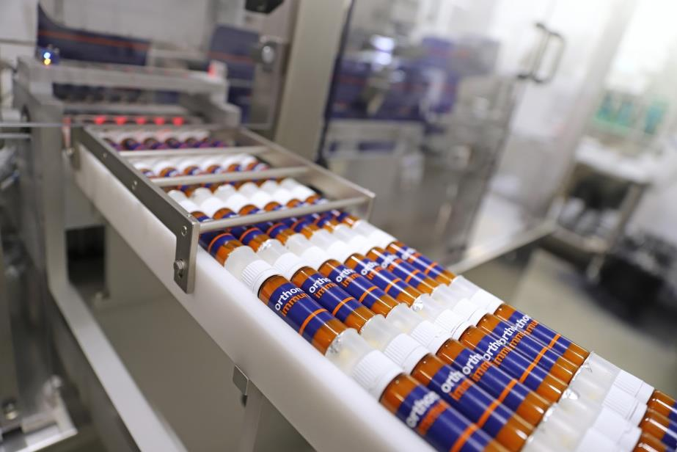  
**Credit:** © Orthomol

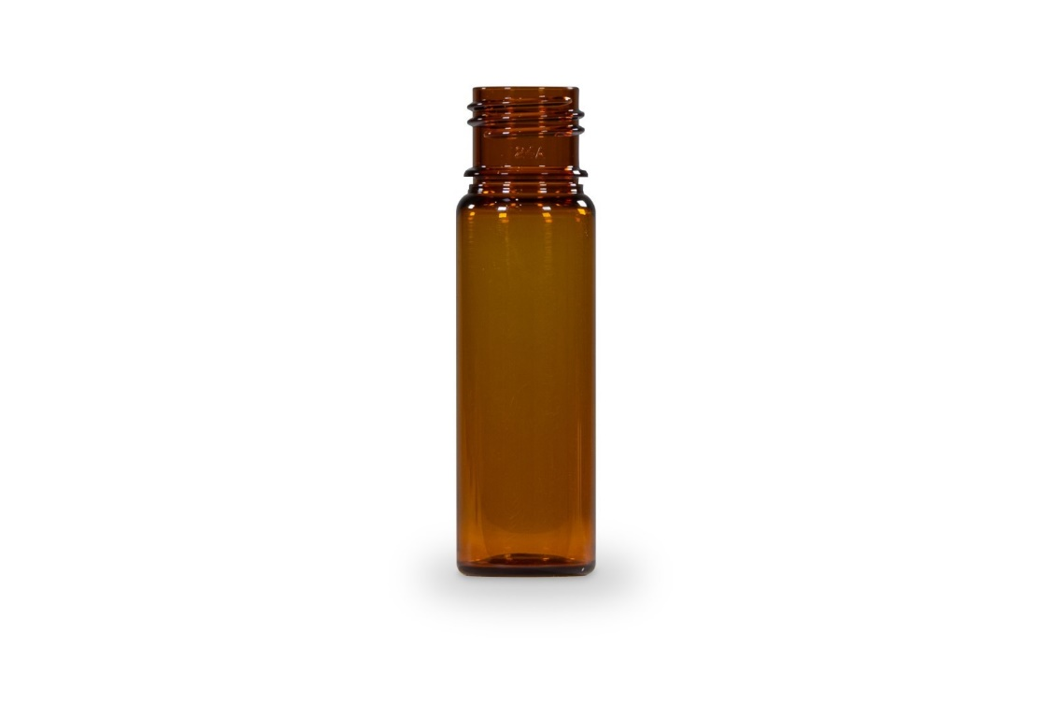  
**Credit**: © Greiner Packaging

**Suggestion for image caption:** Orthomol opts for innovation and sustainability: drinking vials made from recycled PET, produced with Greiner Packaging’s high-tech line.

**About Greiner Packaging**

Greiner Packaging is one of the leading European manufacturers of plastic packaging in the food and non-food sector. For over 60 years, the company has stood for a high level of expertise in finding solutions in development, design, production, and decoration. Greiner Packaging meets the challenges of the market with two business units: Packaging and Assistec. While the former stands for innovative packaging solutions, the latter focuses on the production of customized technical parts. Greiner Packaging employs over 4,900 people at 30 locations in 18 countries worldwide. In 2024, the company achieved an annual turnover of 875 million euros (incl. joint ventures). This is more than 40% of Greiner’s total turnover.

**Greiner Packaging Media Contact:**

Peter Dobosz   
Global Expert PR & Content Marketing

Greiner Packaging International GmbH      
Gewerbestraße 15, 4642 Sattledt, Austria     
Mobile: +43 664 4110735   
E-mail: [p.dobosz@greiner-gpi.com](mailto:p.dobosz@greiner-gpi.com   )