Greiner Packaging Celebrates Success with a
Quartet of Prestigious Packaging Awards

- Greiner Packaging has received four major awards for its innovative, sustainable packaging solutions in the past month, solidifying its leadership in eco-conscious packaging.
- Awards include the Packnorth Award, Austrian State Prize for Smart Packaging, Hungaropack Sustainability Award, and IMDA Award.
- Recognized products feature intelligent and eco-friendly design, demonstrating Greiner Packaging’s commitment to a circular economy.

Kremsmünster, Austria, November 14, 2024. Greiner Packaging is celebrating an exceptional month of recognition, receiving four significant awards for its groundbreaking products. These awards acknowledge Greiner Packaging’s dedication to innovation, environmental responsibility, and the pursuit of a circular economy.

Packnorth Award 2024 for K3® r100 Cup
Greiner Packaging’s K3® r100, a plastic cup encased in a smartly designed cardboard wrap, has been honored with the prestigious Packnorth Award 2024. What sets the K3® r100 apart is its innovative design which allows the materials to separate automatically during the recycling process, ensuring that both the cardboard and plastic components can be efficiently sorted and recycled. This clever design not only minimizes plastic use but also exemplifies Greiner Packaging’s commitment to advancing the circular economy. By simplifying the recycling journey, the K3® r100 cup is a model of sustainable innovation for single-use products.

Austrian State Prize for Smart Packaging: Home-compostable coffee capsules
Greiner Packaging’s home-compostable coffee capsules have earned the Austrian State Prize for Smart Packaging. Offering a solution that breaks down naturally in home compost, these capsules bring eco-conscious convenience to the single-serve coffee experience. To ensure product freshness while upholding home-compostability, Greiner Packaging collaborated with Constantia Flexibles for the sealing lid – a high-barrier, biodegradable solution. Together, the capsule and lid represent an evolution in coffee packaging that meets consumer demand for both quality and environmental responsibility.

Hungaropack Sustainability Award: RFID-Enabled Reusable Drinking Cup
At the Hungaropack Awards, Greiner Packaging received the prestigious Sustainability Award for its reusable drinking cup. Designed for repeated use and crafted from polypropylene (PP), the cup promotes both functionality and eco-conscious design. A standout feature is the integrated RFID chip, which allows for precise tracking and management, making the cup ideal for deposit-return systems and controlled environments. In addition to its smart technology, the cup supports high-quality custom decoration, offering brands an appealing, eye-catching appearance that combines durability and sustainability, meeting consumer demand for reusable, stylish packaging solutions.

IMDA Award for Best Use of IML Technology: In-Mold Labeled Cup
The International In-Mold Decorating Association (IMDA), a prominent authority on in-mold decoration headquartered in the United States, awarded Greiner Packaging the Best Use of IML award for its innovative in-mold labeled (IML) cup. This award celebrates Greiner Packaging’s success in combining striking aesthetics with recyclability. Through IML, the cup achieves high-definition, seamless decoration that catches the consumer’s eye while maintaining compatibility with recycling processes. This award-winning cup exemplifies how Greiner Packaging merges form and function, giving brands a visually captivating and sustainable platform for consumer engagement.

Greiner Packaging’s Commitment to Innovation and the Circular Economy
These awards highlight Greiner Packaging’s pioneering role in advancing the circular economy. Each recognized product showcases the company’s dedication to merging intelligent design with environmental responsibility, furthering Greiner Packaging’s mission to create future-focused, responsible packaging solutions.

Want to learn more about each award and the innovative products behind them? You can find detailed information on each topic here:
Packnorth Award 2024: K3® r100 Cup
Austrian State Prize for Smart Packaging: Home-compostable coffee capsules
Hungaropack Sustainability Award: RFID-Enabled Reusable Drinking Cup
IMDA Award for Best Use of IML Technology: In-Mold Labeled Cup

Text & images:
Text document as well as images in high-resolution quality for download:
https://greinerpackaging.canto.de/b/K935U

Credit: © Greiner Packaging
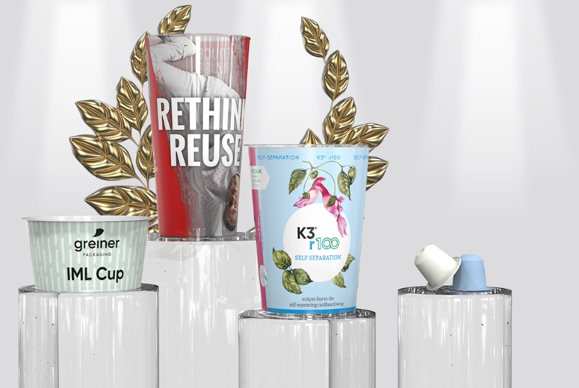
Image caption: Greiner Packaging's award-winning innovations: sustainable single-use and reusable solutions that set new standards in eco-friendly design.

About Greiner Packaging
Greiner Packaging is one of the leading European manufacturers of plastic packaging in the food and non-food sector. For over 60 years, the company has stood for a high level of expertise in finding solutions in development, design, production, and decoration. Greiner Packaging meets the challenges of the market with two business units: Packaging and Assistec. While the former stands for innovative packaging solutions, the latter focuses on the production of customized technical parts. Greiner Packaging employs over 4,800 people at 30 locations in 19 countries worldwide. In 2023, the company achieved an annual turnover of 845 million euros (incl. joint ventures). This is almost 40% of Greiner’s total turnover.

Greiner Packaging Media Contact:
Peter Dobosz
Global Expert PR & Content Marketing

Greiner Packaging International GmbH
Gewerbestraße 15, 4642 Sattledt, Austria
Mobile: +43 664 4110735
E-mail: p.dobosz@greiner-gpi.com

