Greiner Packaging Wins Packnorth Award with K3® r100

- Greiner Packaging has been awarded the Packnews Special Prize within the Packnorth Awards 2024, recognizing outstanding innovation in sustainable packaging.
- The K3® r100 is recognized for its groundbreaking self-separating feature, which simplifies recycling by automatically detaching the cardboard from the plastic.
- The packaging solution offers up to 98% recyclability, reduces plastic use by up to 33%, and promotes sustainability through an eco-friendly design.

Kremsmünster, Austria, November 2024. Greiner Packaging is proud to announce that our K3® r100 cup has received the prestigious Packnews Special Prize at the 2024 Packnorth Awards, held during the Scanpack event in Gothenburg, Sweden. This recognition highlights the cup’s outstanding contribution to advancing circular packaging solutions. Competing against 67 entries, Greiner Packaging's cutting-edge design was selected for its exceptional contribution to sustainable packaging and circularity, marking a significant achievement in driving forward eco-friendly packaging solutions. Recognized for its unique combination of environmental benefits, practicality, and consumer convenience, the K3® r100 can be produced with up to 99% recycled content.
Alongside this honor, Greiner Packaging was also recognized as one of the top five nominees in the highly competitive “Circular and Sustainable Packaging” category. This dual recognition highlights the K3® r100’s impact on sustainable packaging and its leadership in packaging innovations.

About the Award-Winning K3® r100
The K3® r100 represents a major step forward in circular packaging solutions, offering up to 98% recyclability. A key innovation of the K3® r100 is its self-separating feature, designed to ensure easier recycling for both consumers and recycling facilities. This unique feature allows the cardboard outer layer to automatically detach from the plastic container during the waste stream process, eliminating the need for manual separation by the consumer.

Key benefits of the K3® r100 include:
- Self-Separation Technology: The standout feature of the K3® r100 is its ability to self-separate during the recycling process without the need for human intervention. The cardboard wrap detaches from the plastic cup due to the forces in the waste disposal process, simplifying the sorting process and ensuring higher recycling rates.
- Outstanding Level of Recyclability: With its advanced design, the K3® r100 can achieve a recyclability rate of up to 98%, making it one of the most efficient packaging solutions in terms of resource recovery.
- Reduced Plastic Use: The hybrid cardboard-plastic design uses up to 33% less plastic than traditional packaging, helping to conserve valuable resources while still providing necessary product protection and functionality.
- Intuitive Design for Consumer Convenience and Branding: The K3® r100 includes an intuitive tear tab that allows consumers to easily separate the cardboard wrap from the plastic cup if they choose to do so manually. Additionally, its diverse design options and printable inside provide excellent opportunities for communication and differentiation at the point of sale.
- Minimized Environmental Footprint: Due to the thinner walls made possible by reduced plastic content, K3® cups achieve a significantly smaller carbon footprint compared to other packaging alternatives, making them an eco-smart choice.

The K3® r100’s self-separation feature is a breakthrough in recycling-friendly packaging, solving a big challenge in the circular economy - effective material separation. With this innovation, Greiner Packaging continues to demonstrate its commitment to developing practical and sustainable solutions that benefit both consumers and the environment.

A Commitment to a Circular Economy
Greiner Packaging’s win at the Packnorth Awards 2024 highlights the company’s dedication to fostering sustainability in the packaging industry. The K3® r100 is a testament to the company’s focus on creating solutions that align with circular economy principles, where resources are used efficiently, waste is minimized, and materials are continuously recycled.
This prestigious award recognizes the hard work and innovation of the Greiner Packaging team and underscores the company's leadership in sustainable packaging solutions.

About the Packnorth Award
The Packnorth Award is recognized as the largest and most influential packaging competition in the Nordic region, spotlighting breakthrough solutions that are reshaping the future of packaging. The award takes place annually and spans eleven categories. Entries are judged by a panel of experts, including academics and industry professionals, who evaluate each based on category-specific criteria like environmental impact, design ingenuity, and functional effectiveness.

Credit: © Greiner Packaging
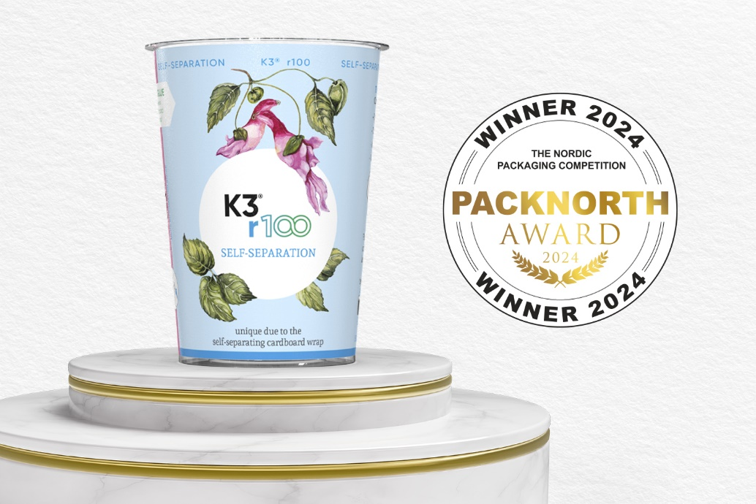
Caption: Greiner Packaging’s award-winning K3® r100, proudly recognized at the Packnorth Award 2024, featuring its innovative self-separating design.

About Greiner Packaging
Greiner Packaging is one of the leading European manufacturers of plastic packaging in the food and non-food sector. For over 60 years, the company has stood for a high level of solution competence in development, design, production, and decoration. Greiner Packaging meets the challenges of the market with two business units: Packaging and Assistec. While the former stands for innovative packaging solutions, the latter focuses on the production of customized technical parts. Greiner Packaging employs over 4,800 people at 30 locations in 19 countries worldwide. In 2023, the company achieved an annual turnover of 845 million euros (incl. joint ventures). This is almost 40% of Greiner’s total turnover.
www.greiner-gpi.com

Greiner Packaging Media Contact:
Peter Dobosz
Global Expert PR & Content Marketing

Greiner Packaging International GmbH
Gewerbestraße 15, 4642 Sattledt, Austria
Mobile: +43 664 4110735
E-mail: p.dobosz@greiner-gpi.com

