Over 610 tons of plastic waste collected: Partnership between Greiner Packaging and Plastic Bank extended again

In 2019, Greiner Packaging launched its partnership with Plastic Bank by supporting the commissioning of five collection points in Manila, Philippines. The partnership was extended for the third time at the end of 2023. A total of over 610 tons of plastic have already been collected as part of the collaboration.

- Greiner Packaging extends its partnership with the social enterprise Plastic Bank dating back to 2019
- Over 610 tons of plastic waste have already been collected and made available for recycling as part of the partnership
- Plastic Bank and its partners (such as Greiner Packaging) are demonstrating both environmental and social responsibility through their commitment

Kremsmünster, April 2024. Greiner Packaging, a leading company in the packaging industry, is pleased to announce that it has extended its long-standing partnership with Plastic Bank for a third time. The extension of this partnership underscores Greiner Packaging’s ongoing commitment to protecting the environment and promoting a sustainable future.

Turning plastic waste into a valuable asset
Plastic Bank is empowering the world to end plastic pollution by building ethical recycling ecosystems in coastal communities and reprocessing the materials collected for reintroduction into the global manufacturing supply chain. Plastic Bank collectors receive a bonus for the plastic they collect, allowing them to earn a higher income. The recycled material is referred to as Social Plastic® feedstock as it offers both environmental and social benefits.

“We are all in agreement: someone has to do something about plastic in the ocean. Plastic Bank and its partners, such as Greiner Packaging, are part of the solution,” says David Katz, who founded Plastic Bank in 2013.

Beatrix Praeceptor, CEO of Greiner Packaging, is thrilled about the renewed partnership: “We’re extremely happy to extend our collaboration with Plastic Bank for the third time. This ongoing partnership reflects our strong commitment to a sustainable future.”

Taking responsibility as an entrepreneurial duty
Sustainable action has always been of paramount importance to Greiner Packaging, a manufacturer of rigid plastic packaging and cardboard-plastic combinations. Under the motto “Join the Circular Revolution!”, the company is calling on its partners along the value chain to commit all their innovative strength to sustainable product solutions. After all, the goal of a sustainable circular economy can only be achieved together.

Acting in the middle of an ecological hotspot
Five plastic collection centers were opened in Manila, the capital of the Philippines, back in 2019. The Philippines is the third-largest producer of plastic waste in the world after China and Indonesia. In the Philippines alone, an estimated 2,000,000 tons of plastic end up in the sea every year. This means that the need for action on the ground is enormous.

“We are aware that we cannot solve the entire plastic waste problem in the Philippines. However, our cooperation has a significant impact on the lives of local people,” explains Beatrix Praeceptor, CEO of Greiner Packaging.

Collectors exchange plastic waste as currency at local Plastic Bank branches for incremental income and access to life-improving benefits such as work and health insurance, meal vouchers, school supplies and more. Offering secure, traceable sources of income and social benefits gives collection communities a way out of poverty.

Impressive results strengthen the continuation of the cooperation
In recent years, over 610 tons of plastic waste have already been removed from the environment in vulnerable coastal areas most impacted by plastic pollution. This weight corresponds to the equivalent of over 30 million plastic bottles.
Currently, 1,660 people across 137 communities in the Philippines benefitted from the partnership.

Plastic Bank currently operates in the Philippines, Indonesia, Thailand, Brazil, and Egypt.

For more information about Greiner Packaging and its parthership with Plastic Bank, please visit the following page: https://www.greiner-gpi.com/en/Sustainability/Our-cooperation-with-Plastic-Bank

Text, video & images:

Text document as well as the images in high-resolution quality for download:
https://greinerpackaging.canto.de/b/PNKOA

Credit: Plastic Bank

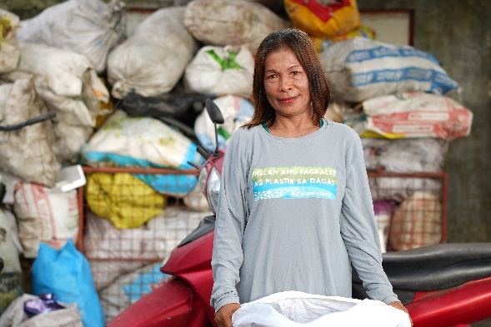
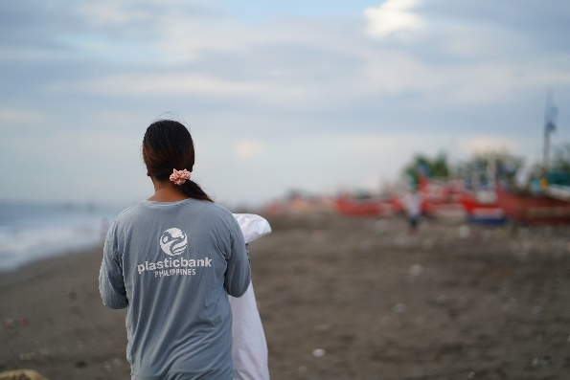

Image caption: Collecting plastic waste in the Philippines. The Plastic Bank concept ensures a clean environment, supports collectors and provides the industry with recycling material.

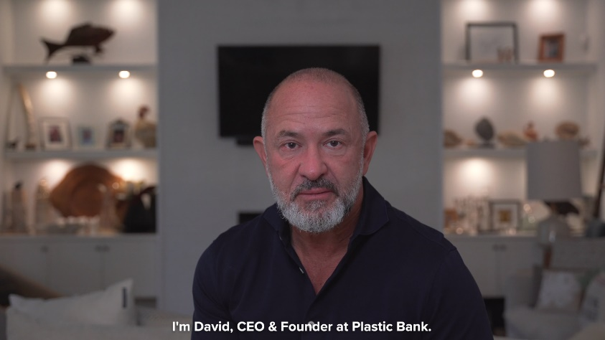
In this video, David Katz, founder of Plastic Bank, talks about the partnership with Greiner Packaging: David Katz about the relationship between Plastic Bank and Greiner Packaging. on Vimeo

About Greiner Packaging
Greiner Packaging is one of the leading European manufacturers of plastic packaging in the food and non-food sector. For over 60 years, the company has stood for a high level of solution competence in development, design, production, and decoration. Greiner Packaging meets the challenges of the market with two business units: Packaging and Assistec. While the former stands for innovative packaging solutions, the latter focuses on the production of customized technical parts. Greiner Packaging employs over 5,000 people at 30 locations in 19 countries worldwide. In 2022, the company achieved an annual turnover of 909 million euros (incl. joint ventures). This is almost 40% of Greiner’s total turnover.

Greiner Packaging Media Contact:
Jörg Sabo

Greiner Packaging International GmbH
Gewerbestraße 15, 4642 Sattledt, Austria
Mobile: +43 664 3240595
E-mail: j.sabo@greiner-gpi.com

