Two WorldStar awards: Successful start to the year for Greiner Packaging

The year 2024 started with a double success for Greiner Packaging: On January 9, it was announced that the company can pride itself on receiving not one, but two WorldStar awards this year, one for its innovative K3® r100 and one for the sustainability-focused redesign of a yogurt packaging.

- Greiner Packaging is the proud winner of no less than two WorldStar awards in the Food category in 2024
- The two prize-winning packaging designs have already received national awards in recent years – which is the requirement for eligibility to be nominated for a WorldStar award

Kremsmünster, January 2024 – A total of 435 packaging products from 41 countries competed for a WorldStar award. Like the submissions, the award winners were equally spread across the globe – including Greiner Packaging, which submitted not one, but two innovative packaging designs.

K3® r100: Self-separation for excellent recyclability
The cardboard-plastic cup was invented by Greiner Packaging over 40 years ago and has been in continuous development ever since. Its thin plastic cup, reduced carbon footprint, and intuitive tear tab make it both a particularly sustainable and visually appealing packaging choice.
The K3® r100 product innovation has made the impossible possible: The cardboard wrap and plastic packaging separate from each other without human intervention during the waste disposal process. This means that achieving a high recyclability rate (up to 98%) does not depend on proper separation by the end consumer – as with all previous K3® packaging: It happens completely independently. Customers such as the Austrian company Berglandmilch and the Swiss dairy Molkerei Forster already trust in self-separating K3® r100. 2023 Greiner Packaging received the Green Packaging Star Award for its innovation.

Customized yogurt packaging: Redesign with sustainability benefits
In order to make the packaging design of Olma Pierot’s creamy, fruity yogurts more sustainable, the brand turned to packaging specialist Greiner Packaging. Switching from injection molding to thermoforming and adapting the cup geometry allowed a total reduction of plastic per cup of 29%. This corresponds to a potential annual savings of 48 tons of plastic. In addition, the packaging is easier to stack thanks to the adjustments made to the cup geometry: The stacking height of 5 cups was reduced by
74.8 mm, which consequently reduces the truckloads required for transport by almost 80% per year. By reducing both the amount of plastic and the number of truckloads required, it is possible to reduce a large amount of CO₂e emissions. Greiner Packaging already received the Czech Obal Roku Award “Packaging of the Year 2023” for the redesign in 2023.

“We have already won several WorldStar awards in recent years. However, receiving two awards in one year is something very special and highlights the fact that – together with our customers – we are working hard at all our locations to develop innovative packaging with a view to sustainability. And it is precisely with this mission that we are entering the upcoming fiscal year,” explains Beatrix Praeceptor, CEO of Greiner Packaging, delighted to have received two WorldStar awards.

The WorldStar Awards competition has been held by the World Packaging Organization since 1970. To qualify for a submission, the packaging must have already won a packaging award at the regional or national level.

Text & image:
Text document as well as images in high-resolution quality for download:
https://greinerpackaging.canto.de/b/RAB03

Credit: Greiner Packaging

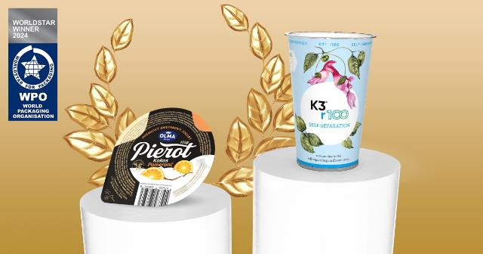

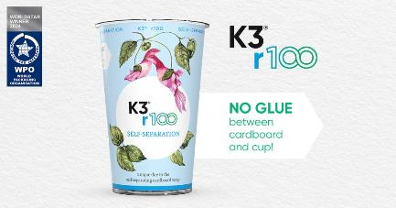

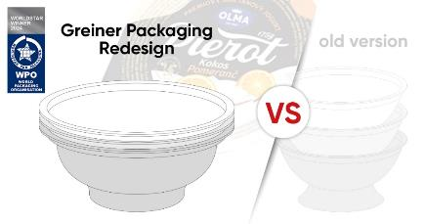

Caption: Greiner Packaging is the proud winner of two WorldStar awards in the Food category in 2024 – one for its K3® r100 and one for its optimized yogurt packaging for the Olma Pierot brand.

About Greiner Packaging
Greiner Packaging is one of the leading European manufacturers of plastic packaging in the food and non-food sector. For over 60 years, the company has stood for a high level of solution competence in development, design, production, and decoration. Greiner Packaging meets the challenges of the market with two business units: Packaging and Assistec. While the former stands for innovative packaging solutions, the latter focuses on the production of customized technical parts. Greiner Packaging employs over 5,000 people at 30 locations in 19 countries worldwide. In 2022, the company achieved an annual turnover of 909 million euros (incl. joint ventures). This is almost 40% of Greiner’s total turnover.

Greiner Packaging Media Contact:
Charlotte Enzelsberger

Greiner Packaging International GmbH
Gewerbestraße 15, 4642 Sattledt, Austria
Mobile: +43 664 88218364
E-mail: c.enzelsberger@greiner-gpi.com

