Molkerei Forster and Lidl Schweiz are launching self-separating packaging from Greiner Packaging

Molkerei Forster is among the first companies in Switzerland to use self-separating K3® cups from Greiner Packaging. The sustainable cardboard-plastic combinations are offered under the proprietary brand Milbona in Lidl Schweiz's retail branches.

- Molkerei Forster is using self-separating cardboard-plastic combinations for its Milbona brand 500 g natural yogurts.
- In the future, the yogurt packaging will enable recovery in separate recycling streams.
- With the conversion to this packaging innovation, Greiner Packaging, Lidl Schweiz and Molkerei Forster are once again emphasizing their focus on sustainability.

Kremsmünster, November. Companies wanting to package dairy products sustainably have been using cardboard-plastic combinations for many years. K3® packaging was first produced at the Swiss Greiner Packaging site in Diepoldsau over 40 years ago. The latest K3® innovation is now coming to the Swiss market: self-separating K3® r100. This innovative packaging is used for the Milbona brand natural yogurts sold by Swiss retailer Lidl Schweiz.

The foundation for optimal recycling laid
For the first time, innovative K3® r100 packaging makes it possible for cardboard and plastic to separate from each other without human intervention. This innovation lays the foundation for future collection systems in Switzerland. If it is forgotten to separate the cardboard wrap from the cup, the two parts separate by mechanical pressure. Plastic cups and cardboard wraps can be identified, assigned to separate recycling streams and consequently recycled. Until this happens, however, both components must continue to be separated manually and sent to the respective (local) disposal system. Greiner Packaging, Lidl Schweiz and Molkerei Forster hope sorting flows will be harmonized in the future. By switching to K3® r100, Molkerei Forster and Lidl Schweiz are already well prepared for such a system and are assuming a pioneering role in future-proof packaging design.

Partnerships ensure innovation
Greiner Packaging and Molkerei Forster have benefited from a partnership-based cooperation for many years and have already developed numerous innovation steps together. In 2021, for example, Molkerei Forster was one of the first companies in Switzerland to use the new Greiner Packaging design: a recess in the cardboard wrap allows easy separation from the plastic cup with just one movement. Close collaboration was required while developing the K3® r100. Numerous filling tests of the packaging innovation took place at Molkerei Forster.

“Without good partners like Molkerei Forster, innovations such as our K3® r100 would not be possible. Before we brought the cup to market, we perfected it in numerous filling tests - including on Molkerei Forster’s systems. Because having a good idea is one thing, checking it for marketability is another. This is only possible in collaboration with our customers,” says Antonios Kampouris, Sales Director of Greiner Packaging Switzerland.

Three companies, one goal
Like Greiner Packaging, Molkerei Forster and retailer Lidl Schweiz are also committed to a sustainable future. “We have set ourselves the goal of focusing on sustainability. This begins with the raw materials used and continues through our production processes to product packaging and beyond. With K3® r100 we are taking another important step towards a sustainable future,” company founder of Molkerei Forster, Markus Forster, says.

500 g tubs are used for Milbona brand natural yogurts with 1.5% and 3.5% fat content sold in Lidl Schweiz branches.

“We have a long-standing and successful partnership. We are pleased to be taking another joint step forward in the packaging sector. By introducing the innovative yogurt packaging, we are once again underlining our commitment to recycling sustainability and design,” says Andreas Zufelde, Chief Commercial Officer at Lidl Schweiz.

Text & image:
Text document as well as images in high-resolution quality for download:
https://greinerpackaging.canto.de/b/PKPCR

Credit: Greiner Packaging

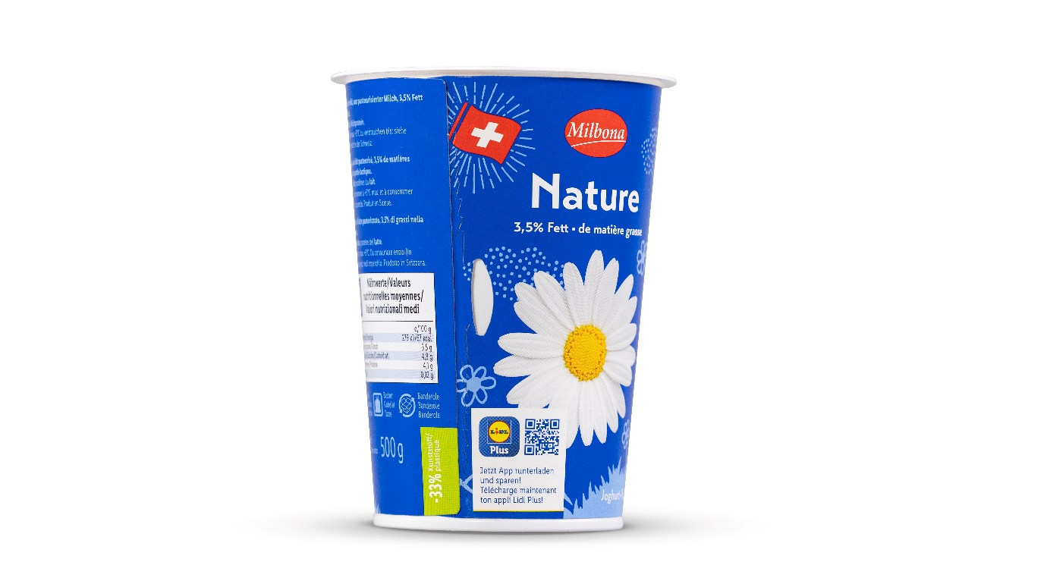

Caption: By switching to self-separating K3® r100 cups from Greiner Packaging, Molkerei Forster and Lidl Switzerland are once again emphasizing their focus on sustainability.

About Greiner Packaging
Greiner Packaging is one of the leading European manufacturers of plastic packaging in the food and non-food sector. For over 60 years, the company has stood for a high level of solution competence in development, design, production, and decoration. Greiner Packaging meets the challenges of the market with two business units: Packaging and Assistec. While the former stands for innovative packaging solutions, the latter focuses on the production of customized technical parts. Greiner Packaging employs over 5,000 people at 30 locations in 19 countries worldwide. In 2022, the company achieved an annual turnover of 909 million euros (incl. joint ventures). This is almost 40% of Greiner’s total turnover.

Greiner Packaging Media Contact:
Charlotte Enzelsberger

Greiner Packaging International GmbH
Gewerbestraße 15, 4642 Sattledt, Austria
Mobile: +43 664 88218364
E-mail: c.enzelsberger@greiner-gpi.com

