Greiner Packaging: air up® relocates tritanTM drinking bottle production to Austria

Kremsmünster. air up® relies on Greiner Packaging for the production of its durable and refillable tritanTM drinking bottles. The bottles will now be produced and assembled in Austria – with ecological and economic advantages.

- German success scale-up relies on know-how and innovative strength of Greiner Packaging
- Entire tritanTM drinking bottle production and assembly now in Upper Austria
- Product improvements lead to higher efficiency and reduced CO₂ footprint
- Relocation of production from China to Austria as a commitment to sustainability

What started in 2016 with an idea and a scientific thesis on the topic of "Neuroscience meets Design" has developed into a successful international company with over 300 employees since the market launch in 2019 – air up®. The five founders of the Munich-based scale-up developed a revolutionary drinking system that gives conventional tap water flavor only through scent. To do this, a pod filled with natural aromas is placed on the mouthpiece of the drinking system filled with tap water. When drinking from the straw, you simultaneously draw flavored air into your throat along with the water. From there, the scent molecules reach our olfactory center and are perceived as taste when we exhale. In short, our brain thinks we are tasting cherry, peach, or apple, when we are only consuming water.

Sustainability as #workinprogress
air up® had its goal in mind from the very beginning: "sustainability by design". Hence the principle of the high-quality and durable drinking bottle made of tritanTM, which can accordingly replace the use of disposable bottles for daily drinking. A simple calculation: if you enjoy three flavor pods from the air up® product portfolio, you can potentially save around 15 PET disposable plastic bottles.

Production of the innovative drinking bottles was initially handled by Chinese partners due to a lack of network and resources. From the very beginning, however, it was a matter close to the hearts of the air up® founders to constantly improve themselves and their products in order to keep the ecological footprint as small as possible in the future. Consequently, with the goal in mind to take another step towards sustainability, today's scale-up started looking for suitable suppliers in Europe at a very early stage. In the end, Greiner Packaging prevailed.

Magdalena Jüngst, co-founder and Chief Evangelist of air up®, says: "Our goal was crystal clear from the very beginning: we wanted to move our production to Europe as quickly as possible. However, this is much more complex than it sounds. We needed a highly automated plant to produce our complex drinking system, to meet our high quality standards, and also an appropriate team. We are pleased to have found the ideal partner in Greiner Packaging and are proud to have come one step closer to our goal of reducing the distance between our production and our customers."

Greiner Packaging scored with innovative ideas and sustainable approaches
Greiner Packaging sees itself as an innovative company that – true to its motto "do the innovation" – wants to get the best out of products. This is also what happened with air up®:
In its search for a European producer for its bottles, Greiner Packaging was able to impress with several, innovative ideas at once.

On the one hand, the bottle was previously lacquered to achieve its typical matt effect look. Greiner Packaging now relies on a masterbatch solution. This allows the same effect to be realized, but already as part of the bottle production process. Thus, no additional production

step at another supplier is necessary. This saves logistics costs and, above all, CO₂ – through savings in production and transport.

In addition, the straw was redesigned in the course of development: It is now produced by injection molding instead of extrusion blow molding as before and can thus be manufactured even more precisely. In addition, the cardboard packaging of the bottles has also been optimized. A specialist for high-quality packaging from Upper Austria was brought on board for this: packit! Verpackungen GmbH. The cardboard packaging is now made of 100% recycled cardboard and does not require a plastic coating; the matte design effect is achieved by means of printing.

"The entire development project around air up® was an invitation for us to show our strengths in terms of the customer and sustainability. We have a lot of experience and know-how. Coupled with innovative strength and in close exchange with our customer air up®, we were thus able to make the unique drinking bottle system from air up® a little more sustainable. We are proud of this," says Rene Berger, CEO Greiner Packaging Austria.

"We are pleased that we were able to contribute our expertise and thus help shape the cardboard packaging of air up® in a more sustainable way. To meet the challenges of complex packaging, we have also invested in our machinery and purchased a unique diecutter. The innovative character and the partnership-based cooperation, both with Greiner Packaging and with air up®, particularly distinguish this project”, says Karl Ömmer, CEO of packit! Verpackungen GmbH.

Everything from a single source
With the relocation of the production to Austria, Greiner Packaging is now responsible for the majority of the product components produced: from the drinking bottle made of TritanTM, to the injection-molded lid made of ABS (acrylonitrile-butadiene-styrene copolymer), and the injection-molded straw made of HDPE (high-density polyethylene). Only the mouthpiece and handle tab made of silicone are currently delivered to the packaging expert. The assembly of the bottle and the packaging are also carried out by Greiner Packaging in Austria. The finished air up® drinking systems, packed and ready for shipment to the consumer, finally go directly from Austria to the air up® warehouse, where they are ready for distribution to large parts of Europe and the USA.

A lot of experience in single-step injection stretch blow molding
Greiner Packaging already has more than 60 years of experience in the production of plastic packaging solutions. The company scores with great know-how in a wide range of production technologies and also understands its added value for customers in this technological breadth. This diversity also proved to be a great advantage for air up®, as the company could expect the best solution for each individual product part of the bottle. In particular, Greiner Packaging's expertise in the field of single-step, high-quality injection stretch blow molding benefited the further development of the air up® bottles. Above all, the angled neck of the bottle requires the highest precision in the production process, which Greiner Packaging can guarantee to its customer air up®.

Text and image:
Text document and high-resolution images for download:
https://greinerpackaging.canto.de/b/G2EAO
Images for royalty-free use, credit: air up®, Greiner Packaging

Credit: Greiner Packaging
Caption: air up® tritanTM drinking bottles are now produced and assembled at Greiner Packaging in Austria – with numerous ecological and economic advantages.

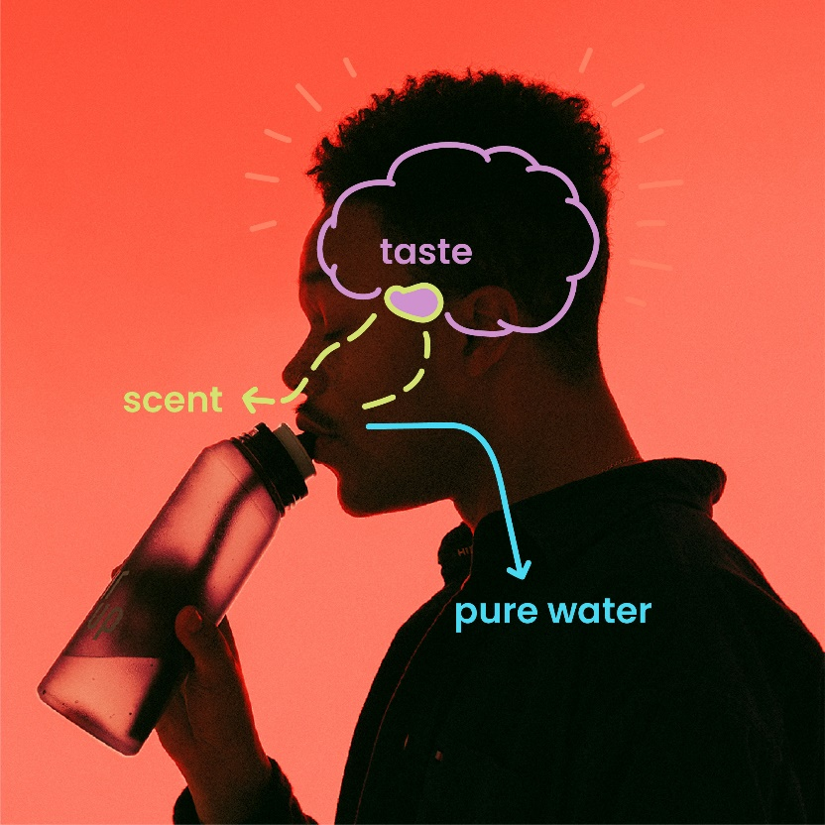

Credit: air up®
Caption: Revolutionary air up® drinking bottle system: Our brain thinks we are tasting cherry, peach or apple, when we are actually only consuming water.

About Greiner Packaging
Greiner Packaging is a leading European manufacturer of plastic packaging in the food and nonfood sectors. The company has enjoyed a reputation for outstanding solutions expertise in the fields of development, design, production, and decoration for over 60 years. Greiner Packaging responds to the challenges of the market with two business units: Packaging and Assistec. While the Packaging unit focuses on innovative packaging solutions, the Assistec unit is dedicated to producing custom-made technical parts. Greiner Packaging employs a workforce of more than 5.000 at more than 30 locations in 19 countries around the world. In 2022, the company generated annual sales revenues of EUR 909 million (including joint ventures), which represents almost 40% of Greiner’s total sales.

Media contact for Greiner Packaging:
Alexandria Mitterbaur
Global Head of Marketing

Greiner Packaging International GmbH
Gewerbestraße 15, 4642 Sattledt, Austria
Mobile: +43 664 88218434
E-mail: A.Mitterbaur@greiner-gpi.com

