“Reduce, reuse, recycle”: Greiner Packaging presents targeted solutions at FachPack 2022

Greiner Packaging will showcase its latest product developments in line with all three elements of the “reduce, reuse, recycle” principle at FachPack from September 27 to 29. Food packaging made of r-PET and the self-separating cardboard-plastic cup K3® r100 will be among the highlights.

Kremsmünster, Austria (September 2022). With their slogan, “Join the circular revolution!” the packaging experts at Greiner Packaging are calling on customers and industry colleagues to join them on the path to a sustainable circular economy. At FachPack in Nuremberg, Germany, the company will present the solutions it has developed to help achieve this goal.

Keeping PET in circulation
By acquiring its first recycling company – Serbian producer of r-PET flakes, ALWAG – Greiner Packaging has entered the recycling business and taken a vital step on its journey into a sustainable future. Taking over the Serbian location, which will operate under the name Greiner Recycling d.o.o. going forward, secures important material streams for the company and reinforces its commitment to promoting a circular economy. Greiner Packaging recognizes the potential of circular-ready PET and has set itself the goal of driving forward the development of a PET tray-to-tray recycling stream to complement the existing bottle stream, which already functions well. This backward integration step is an important milestone on the journey.

At FachPack in Nuremberg, the company will present packaging solutions made of up to 100% r-PET that it has already successfully implemented and reveal what the food packaging of the future could look like – whether for salads, spreads, convenience foods, or dairy products. In the future, it will even be possible to use r-PET for products requiring hot sterilization by utilizing the temperature-stable material r-PET HTS®.

K3® r100: the self-separating cup
One innovation that combines two of the “Rs” – reduce and recycle – is the self-separating cardboard-plastic combination K3® r100. The cardboard wrap, which lends sturdiness to the thin walls of the plastic cup, separates itself from the cup during the waste collection process. This means that the cardboard and plastic can be assigned to the correct material streams during the initial sorting process, before the packaging even arrives at the recycling facility – an innovative development that makes cardboard-plastic combinations substantially easier to recycle.

Reusing what can be used again
At FachPack, in an area dedicated to reuse, the plastics experts will present a range of sustainable packaging solutions that are reuse-ready. After all, this is a business segment that is booming and experiencing increasing demand, especially among consumers. The company’s showcase will include Reuse Drinking Cups and Reuse Bowls – designs that have been specially created for reuse systems and are suitable for hot and cold beverages or dishes at any temperature.

Working together toward a more sustainable future
Greiner Packaging will be exhibiting these and a host of other innovative and future-facing solutions at FachPack. The packaging specialists are particularly looking forward to speaking with visitors and other industry experts. After all, we have to work together if we want to make a global circular economy a reality.

Greiner Packaging at FachPack 2022:
Hall 7 (7-436)

Further press releases relating to Greiner Packaging’s efforts to boost sustainability can be found here:

Press release on the takeover of an r-PET flake producer
Press release on 100% r-PET packaging for Harvest Moon
Information about K3® r100

Text and image:

Text document and high-resolution images for download:
https://mam.greiner.at/pinaccess/showpin.do?pinCode=O2aISjWa5EOo

Photo credit: Greiner Packaging

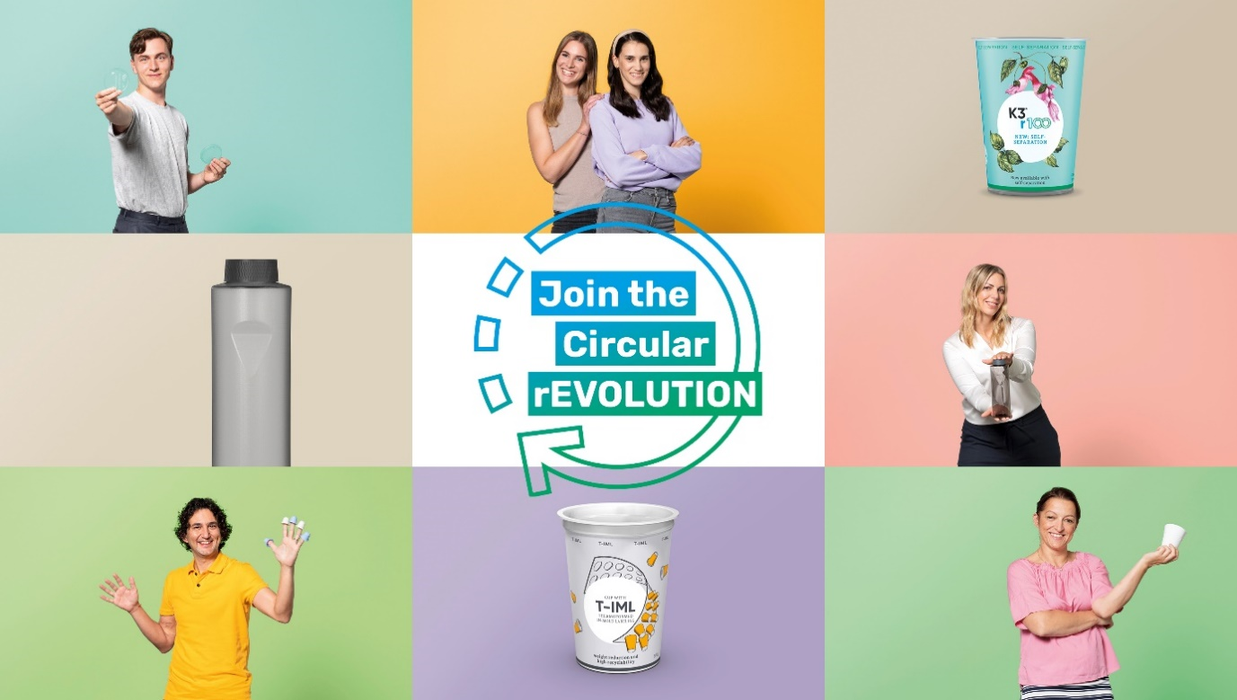

Caption: “Join the circular revolution” is Greiner Packaging’s motto. The new campaign aims to shine a spotlight on sustainable packaging solutions that embody the “reduce, reuse, recycle” maxim.

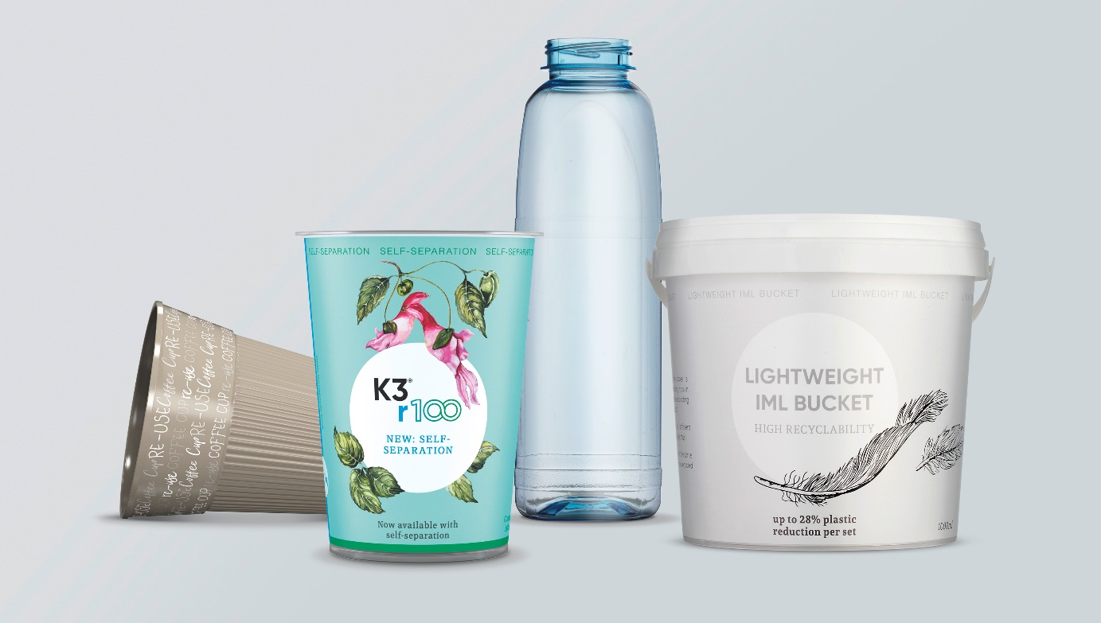
Caption: At FachPack, Greiner Packaging will be showcasing a host of products that reflect the “reduce, reuse, recycle” approach, including the Reuse Drinking Cup, K3® r100, reusable and lightweight packaging, and various solutions made of r-PET.

About Greiner Packaging

Greiner Packaging is a leading European manufacturer of plastic packaging in the food and nonfood sectors. The company has enjoyed a reputation for outstanding solutions expertise in the fields of development, design, production, and decoration for over 60 years. Greiner Packaging responds to the challenges of the market with two business units: Packaging and Assistec. While the Packaging unit focuses on innovative packaging solutions, the Assistec unit is dedicated to producing custom-made technical parts. Greiner Packaging employs a workforce of over 4,900 people at more than 30 locations in 19 countries around the world. In 2021, the company generated annual sales revenues of EUR 772 million (including joint ventures), which represents almost 35% of Greiner’s total sales.

Media contact for Greiner Packaging:
Charlotte Enzelsberger
Global communication expert

Greiner Packaging International GmbH
Gewerbestrasse 15, 4642 Sattledt, Austria
Cell: +43 664 88218364
Email: C.Enzelsberger@greiner-gpi.com
Website: www.greiner-gpi.com

Further information:
www.greiner-gpi.com

