Plastics Recycling Awards Europe 2022 finalist: self-separating cup K3® r100 highlights importance of sustainable packaging innovations

With its K3® r100 design, Greiner Packaging has succeeded in developing a sustainable packaging solution whose cardboard wrap separates from the plastic cup all by itself en route to the recycling plant. This maximizes the product’s recyclability and shows what innovation in the packaging industry is all about. K3® r100 has earned Greiner Packaging a position among the finalists of the Plastics Recycling Awards Europe, which recognize achievements throughout the European plastics recycling industry.

Kremsmünster, Austria (June 2022). The Plastics Recycling Awards Europe are presented annually in recognition of outstanding achievements in the European plastics recycling industry. The awards put a spotlight on the latest developments in the use of recycled material, product design, and innovative manufacturing across Europe, bringing together key players from the plastics and recycling sectors. With K3® r100, Greiner Packaging has secured a place among the top finalists in the Product Technology Innovation of the Year 2022 category.

K3® r100: the self-separating cup
It is obvious why K3® r100 was chosen as a finalist for 2022’s top product innovation: Until now, separating cardboard-plastic combinations has been heavily dependent on consumer cooperation. But in the case of K3® r100, the two materials separate on their own – even while they are still on the way to the recycling plant. This means that the cardboard and plastic can be assigned to the correct material streams during the initial sorting process before being recycled. However, the K3® r100 design also retains the intuitive and easy-to-use tear-off solution, which allows consumers to keep separating the packaging into its components themselves.

An innovation for a sustainable packaging industry
With K3® r100, Greiner Packaging has introduced a packaging solution that can be recycled more effectively than alternative options, giving it a much smaller carbon footprint. The design has been certified with a recyclability rating of above 90% by Cyclos-HTP* and has been given a Class A ranking by RecyClass**, indicating the top level of recyclability for a packaging item.

“We are very pleased that our efforts to provide innovative packaging solutions have been met with such a positive response and are attracting attention in the industry. The fact that K3® r100 has been named as a finalist for the Product Technology Innovation of the Year 2022 award shows that we are heading in the right direction and that our hard work is paying off,” said a proud Konrad Wasserbauer, global circular economy director at Greiner Packaging, at the awards ceremony.

* In Germany and France
** This rating applies to the plastic part of the packaging only, as the recyclability of the cardboard wrap depends on the infrastructure in place in individual countries and varies within the European Union.

https://www.greiner-gpi.com/en/Products/Product-innovations/K3-r100

Text and image: Greiner Packaging

Text document and high-resolution images for download:
https://mam.greiner.at/pinaccess/showpin.do?pinCode=nvWWmodqOHlq

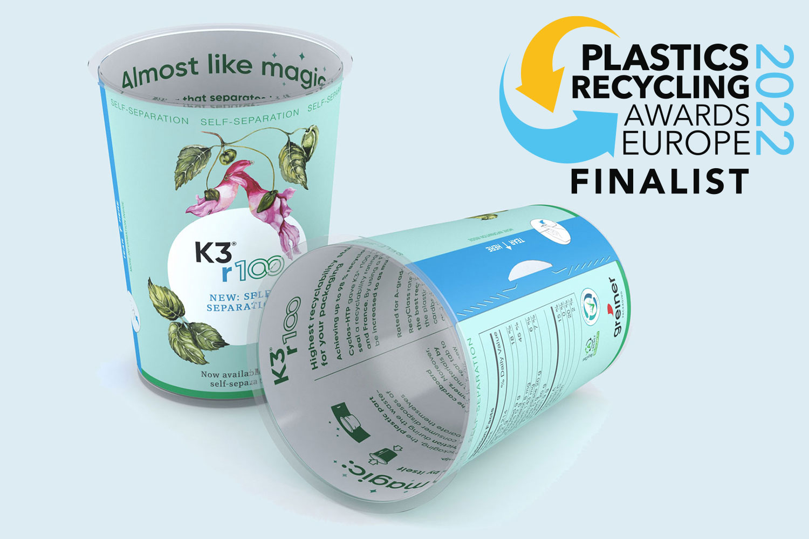

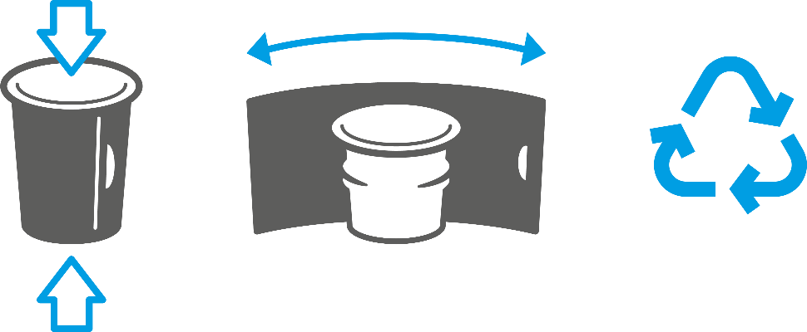

Caption:
K3® r100, an innovation from Greiner Packaging enables automatic separation of cardboard and plastic on the way to the recycling facility. The packaging solution was listed as a finalist in the Plastics Recycling Awards Europe 2022.

About Greiner Packaging

Greiner Packaging is a leading European manufacturer of plastic packaging in the food and nonfood sectors. The company has enjoyed a reputation for outstanding solutions expertise in the fields of development, design, production, and decoration for over 60 years. Greiner Packaging responds to the challenges of the market with two business units: Packaging and Assistec. While the Packaging unit focuses on innovative packaging solutions, the Assistec unit is dedicated to producing custom-made technical parts. Greiner Packaging employs a workforce of more than 4,900 at more than 30 locations in 19 countries around the world. In 2021, the company generated annual sales revenues of EUR 772 million (including joint ventures), which represents almost 35% of Greiner’s total sales.

Media contact at Greiner Packaging:
Roland Kaiblinger I Account Executive
SPS MARKETING GmbH | B 2 Businessclass | Linz, Stuttgart
Jaxstrasse 2–4, 4020 Linz, Austria
Tel.: +43 (0) 732 60 50 38-29
E-Mail: r.kaiblinger@sps-marketing.com
www.sps-marketing.com

More information:
www.greiner-gpi.com

