K3® r100: the self-separating cup

An innovative development from Greiner Packaging is revolutionizing the recyclability of cardboard-plastic combinations. Making sure that waste was sorted correctly used to be fully reliant on consumers playing their part. But now with K3® r100, the cardboard wrap and the plastic cup separate all by themselves on the way to the recycling facility. This makes the packaging solution ideal for recycling.

Kremsmünster, Austria (September, 2021) – Cardboard-plastic combinations have a number of positive attributes when it comes to sustainability. The cardboard wrap, which can be made from recycled material, lends sturdiness to the plastic cup so that it can be produced with particularly thin walls. This wrap is especially easy to detach from the cup thanks to an innovative tear-off system, with the two components then disposed of separately and recycled. Since the white or transparent plastic cup is unprinted, it can be recycled very effectively. In addition, the carbon footprint of K3® cups is significantly smaller than that of alternative packaging solutions. “Cardboard-plastic combinations are a fully sustainable solution,” emphasizes Jens Krause, sales director and K3® product category manager at Greiner Packaging. “But there is one challenge – separating the cardboard wrap from the plastic cup currently requires action by consumers. If they separate the cardboard wrap from the plastic cup when discarding the used packaging, the cup will perform very well in the recycling process. But if they don’t do that – which is still the case for most consumers – the components will not always be correctly identified in the sorting system, making it difficult to correctly recycle the K3® packaging. As a result, the cups are currently quite difficult to recycle properly in some countries.”

Innovative solution for maximum recyclability: K3® r100
Greiner Packaging wants to address this state of affairs – and is now introducing a packaging product like no other. In developing K3® r100, the packaging specialists have created a solution in which the cardboard wrap separates itself from the plastic cup during the waste collection process – i.e., before the packaging arrives at the recycling facility. This innovative development makes K3® cups substantially easier to recycle, with the cardboard and plastic assigned to the correct material streams during the initial sorting process before being recycled.

Top scores
Cyclos-HTP has given K3® r100 (with a standard aluminum lid) a recyclability rating of higher than 90 percent.* RecyClass has also issued K3® r100 its best rating (Class A) – the K3® cup was evaluated and certified in accordance with RecyClass recyclability standards and the Design for Recycling guidelines and received a Class A rating, indicating the top level of recyclability for a packaging item.**

Major breakthrough
“In developing K3® r100, we have made a major breakthrough. That being said, of course, the best-case scenario is still for the consumer to separate the cardboard wrap from the plastic cup before disposing of the parts properly,” Krause stresses. For this reason, the K3® r100 still features the innovative tear-off solution, which makes separating the plastic and cardboard easier and more intuitive. This means that environmentally conscious consumers can play it safe when it comes to recycling – it was with good reason that the tear tab was praised by the jury for the Swiss Packaging Awards for being “easy to see and use” and “self-explanatory.” Plus, the rear side of the cardboard wrap is the perfect place to provide more information and engage with consumers.

K3® r100 will come onto the market this fall. Greiner Packaging will be exhibiting the innovative solution at FachPack.

* In Germany and France.
** This rating is for the plastic part of the packaging only, as the recyclability of the cardboard wrap depends on the infrastructure in place in individual countries and varies within the European Union.

Text and image: Greiner Packaging

Text document and high-resolution images for download:
https://mam.greiner.at/pinaccess/showpin.do?pinCode=NJ6V8WWM3J60

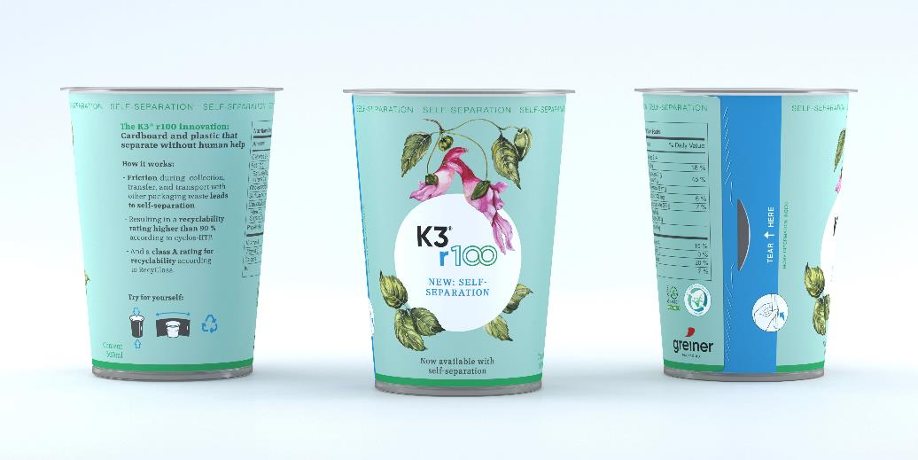

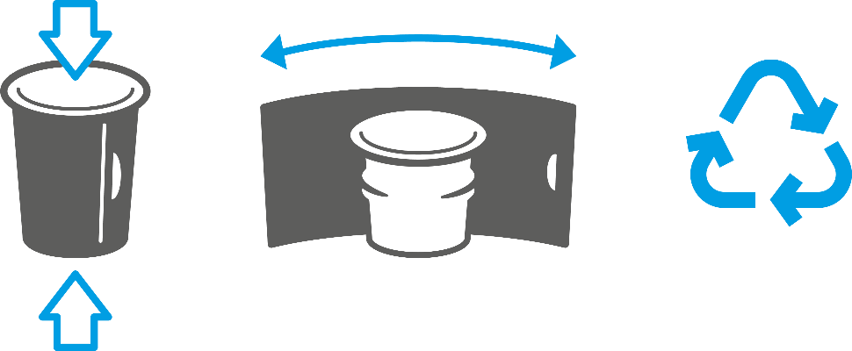

Caption:
A new Greiner Packaging innovation enables self-separation of cardboard-plastic combinations on the way to the recycling facility. This makes the new K3® r100 packaging solution ideal for recycling.

About Greiner Packaging

Greiner Packaging is a leading European manufacturer of plastic packaging in the food and nonfood sectors. The company has enjoyed a reputation for outstanding solutions expertise in the fields of development, design, production, and decoration for more than 60 years. Greiner Packaging responds to the challenges of the market with two business units: Packaging and Assistec. While the Packaging unit focuses on innovative packaging solutions, the Assistec unit is dedicated to producing custom-made technical parts. Greiner Packaging employs a workforce of nearly 4,900 at more than 30 locations in 19 countries around the world. In 2020, the company generated annual sales revenues of EUR 692 million (including joint ventures), which represents approximately 35 percent of Greiner’s total sales.

Media contact at Greiner Packaging:
Roland Kaiblinger I Account Executive
SPS MARKETING GmbH | B 2 Businessclass | Linz, Stuttgart
Jaxstrasse 2–4, 4020 Linz, Austria
Tel.: +43 (0) 732 60 50 38-29
E-Mail: r.kaiblinger@sps-marketing.com
www.sps-marketing.com

More information:
www.greiner-gpi.com

