Trigos 2021: award received for sustainable school milk project

In a world first, school milk is now being supplied in 100 percent sustainable cups made of recycled PET (r-PET) in the state of Upper Austria. The innovation comes courtesy of a collaboration between Austria’s school milk producers and three Upper Austrian companies: PET-MAN, Greiner Packaging, and Starlinger Viscotec. This joint project is revolutionizing the packaging market and showing that a sustainable circular economy is possible. On September 16 the project partners received recognition for their work by winning a Trigos – the Austrian award for companies that do business responsibly.

Kremsmünster, Austria (September, 2021) – The Trigos Awards are Austria’s most prestigious series of accolades for responsible business and were presented for the eighteenth time in 2021. The awards aim to stimulate corporate social responsibility and sustainable innovation in the Austrian economy, while also giving credit to companies that are actively helping to prepare our society for the future. Among these were Greiner Packaging, which received an award in the exemplary projects category for its Sustainably Packaged School Milk project, alongside all of its partners.

100% r-PET – a closed recycling loop
The project, which promotes closed-loop recycling, is achieving impressive results. Austria’s school milk producers supply schools and kindergartens directly with dairy products in r-PET cups. The children consume the drinks during recess, then the used cups are gathered and returned for recycling to the school milk producers. Once collected, these containers are picked up from the farm, washed, and shredded. The resulting flakes are then cleaned and processed. At Greiner Packaging, the extruded plastic sheet is ultimately used to thermoform new r-PET cups, which are then refilled by the farmers and delivered once again to schools and kindergartens. This closed loop releases over 30 percent less CO₂ than reusable glass bottles. Recycling the cups also requires less energy than processing reusable glassware, for instance, and produces less waste. Crucially, the only reason the cups can be recycled so easily is that they are unprinted and made from 100 percent monomaterial.

Regional product in regional packaging
The entire school milk loop takes place within Upper Austria. The cows graze in local pastures, and the cups are filled with fresh milk at the dairy farms before being delivered to the schools. Thanks to the partnership between local businesses PET-MAN, Greiner Packaging, and Starlinger Viscotec, locally produced school milk can be supplied to kindergartens and schools in Upper Austria.

“Needless to say, we are delighted that our commitment to school milk in Upper Austria was recognized with a Trigos. The award shows that we are on the right track. For us, sustainability is not just a catchphrase – it is a duty we take very seriously. Thanks to the project, children can be taught to treat nature sustainably from a young age. After all, it makes a real difference whether we throw away packaging or whether we are able to keep recycling it. If we can help raise awareness of that, then we have done a good job,” said Manfred Stanek, CEO of Greiner Packaging, at the awards ceremony.

r-PET: material of the future
The recycling loop for r-PET makes it a material with a promising future. And as things stand, recycled PET is the only postconsumer secondary plastic approved for food applications in the EU. The white r-PET packaging can be reprocessed into food packaging, making it the ideal recyclable packaging solution for dairy products.

Technology facts:

- Technology: Thermoforming
- Decoration: None – making it ideal for recycling
- Material: r-PET
Text and image:

Text document and high-resolution images for download:
https://mam.greiner.at/pinaccess/showpin.do?pinCode=ypWKJiCd7lZF

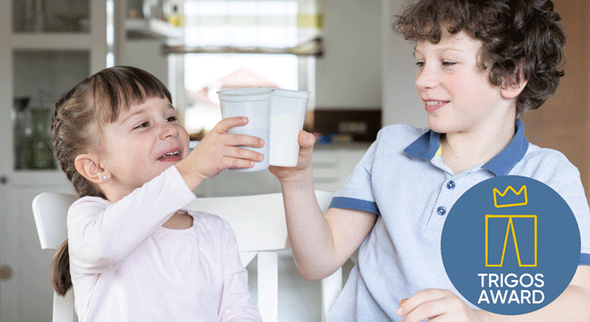

Caption:
In a world first, school milk is now being supplied in 100 percent sustainable cups made of recycled PET (r-PET) in the state of Upper Austria. The project has now been honored with a TRIGOS, the Austrian award for companies that do business responsibly.

About Greiner Packaging

Greiner Packaging is a leading European manufacturer of plastic packaging in the food and nonfood sectors. The company has enjoyed a reputation for outstanding solutions expertise in the fields of development, design, production, and decoration for more than 60 years. Greiner Packaging responds to the challenges of the market with two business units: Packaging and Assistec. While the Packaging unit focuses on innovative packaging solutions, the Assistec unit is dedicated to producing custom-made technical parts. Greiner Packaging employs a workforce of nearly 4,900 at more than 30 locations in 19 countries around the world. In 2020, the company generated annual sales revenues of EUR 692 million (including joint ventures), which represents approximately 35 percent of Greiner’s total sales.

Media contact at Greiner Packaging:
Roland Kaiblinger I Account Executive
SPS MARKETING GmbH | B 2 Businessclass | Linz, Stuttgart
Jaxstrasse 2–4, 4020 Linz, Austria
Tel.: +43 (0) 732 60 50 38-29
E-Mail: r.kaiblinger@sps-marketing.com
www.sps-marketing.com

More information:
www.greiner-gpi.com

