Greiner Packaging develops sustainable cardboard-plastic packaging for new Somat Excellence 4in1 dishwasher caps from Henkel

As a manufacturer of sustainable plastic packaging, Greiner Packaging is constantly in the business of responding to new product types and requirements. One recent example is the new Somat Excellence 4in1 dishwasher caps from Henkel. These use a unique technology that combines powder and three solid gel chambers, which consumers will only have seen from laundry detergent products to date. The caps are securely packaged in cardboard-plastic combinations and an innovative lid solution from Greiner Packaging.

Kremsmünster, Austria, June 2021. Brand owner Henkel is now using the sustainable cardboard-plastic tubs from Greiner Packaging, which contain 50 percent postconsumer recycled PP from end consumer households, in a new, innovative product for the Somat brand. The tubs previously received the World Star Award 2021 in recognition of the packaging for Persil 4in1 Discs, another Henkel product. This is a great example of how Greiner Packaging and Henkel continue to develop together based on a close, ongoing relationship – including making their packaging solutions more sustainable.

“Our longstanding customer Henkel was looking for an innovative, end-to-end packaging solution for the new Somat Excellence 4in1 caps, which are dishwasher detergent capsules containing both powder and three solid gel chambers. An effective seal to prevent moisture from getting into the packaging was especially important, and Greiner Packaging delivered an ideal solution by providing both the tub and lid,” says Andreas Auinger, international project manager at Greiner Packaging. “The main challenge in developing this packaging was the product inside, as the 4in1 caps are extremely sensitive to moisture. So the key requirement for the packaging was to ensure a perfect seal during both transport and storage,” Auinger adds.

Tub made from recyclable material for positive environmental impact
Thanks to its innovative, patented tear-off system, the cardboard wrap and the plastic tub can be easily separated and recycled. Because the two components can be separately added to their respective recycling loops, the consumer benefits from a highly recyclable packaging solution. The wrap is made of cardboard consisting of nearly 100 percent recycled material. Greiner Packaging uses a two-stage process for the plastic tub itself: The inside of the plastic tub is made from white virgin material, which guarantees an optimal color contrast with the colorful 4in1 caps. The packaging’s outer coating, meanwhile, contains 50 percent r-PP obtained from end consumer households. This layer’s gray color has no impact on the packaging’s look, because it comes wrapped in an attractively printed cardboard sleeve.

Innovative lid for impenetrable seal
Greiner Packaging also supplies the lids for Henkel’s new packaging for Somat Excellence 4in1 caps. The team developed a special concept for Henkel, featuring a sealing film that is built into the lid to provide an outstanding seal. Plus, the opening of the tub is calibrated ahead of time so that it fits with absolute precision – and the lid and tub fit together perfectly. These two special characteristics of the lid guarantee the best protection for the caps along with a top-class seal to prevent moisture from getting in.

“The new packaging for the Somat Excellence 4in1 dishwasher caps stands out not only thanks to its sustainable properties and premium shelf appeal but also because of its high degree of technical functionality. Based on our experiences with other similarly designed packaging solutions, we already know that this type of smart, sustainable packaging from our partner Greiner Packaging is a big hit with consumers. Besides the new innovative Somat Excellence 4in1 caps, we also use the same packaging principle for the Somat Gold dishwasher tablets,” notes Carsten Bertram, senior manager for international dishwashing packaging development at Henkel.

Logistical excellence with K3®
Cardboard-plastic combinations also impress when it comes to logistics in the form of K3®-F packaging solutions. These lids, plastic tubs, and folded cardboard wraps are delivered separately to Henkel. Greiner Packaging’s longstanding joint venture partner, Cardbox Packaging, supplies the wraps, which are then folded and slipped over the tub directly before filling at the company. This ensures a high degree of flexibility in production and keeps stocks to a minimum.

Packaging facts:

Tub:
- Material: PP (50 percent recycled material)
- Technology: Thermoforming
- Decoration: Cardboard sleeve

Lid:
- Material: PP with integrated aluminum sealing film
- Technology: Injection molding

About Greiner Packaging
Greiner Packaging is a leading European manufacturer of plastic packaging in the food and nonfood sectors. The company has enjoyed a reputation for outstanding solutions expertise in the fields of development, design, production, and decoration for more than 60 years. Greiner Packaging responds to the challenges of the market with two business units: Packaging and Assistec. While the Packaging unit focuses on innovative packaging solutions, the Assistec unit is dedicated to producing custom-made technical parts. Greiner Packaging employs a workforce of around 4,900 at more than 30 locations in 19 countries around the world. In 2020, the company generated annual sales revenues of EUR 692 million (including joint ventures), which represents more than 35% of Greiner’s total sales.
For more information please visit: www.greiner-gpi.com/en

About Henkel
Henkel operates globally with a well-balanced and diversified portfolio. The company holds leading positions with its three business units in both industrial and consumer businesses thanks to strong brands, innovations and technologies. Henkel Adhesive Technologies is the global leader in the adhesives market – across all industry segments worldwide. In its Laundry & Home Care and Beauty Care businesses, Henkel holds leading positions in many markets and categories around the world. Founded in 1876, Henkel looks back on more than 140 years of success. In 2020, Henkel reported sales of around 19 billion euros and adjusted operating profit of around 2.6 billion euros. Henkel employs around 53,000 people globally – a passionate and highly diverse team, united by a strong company culture, a common purpose to create sustainable value, and shared values. As a recognized leader in sustainability, Henkel holds top positions in many international indices and rankings. Henkel’s preferred shares are listed in the German stock index DAX. For more information, please visit www.henkel.com

Text and images:

Text document and high-resolution images for download:

https://mam.greiner.at/pinaccess/showpin.do?pinCode=Uzfo2V2sHati

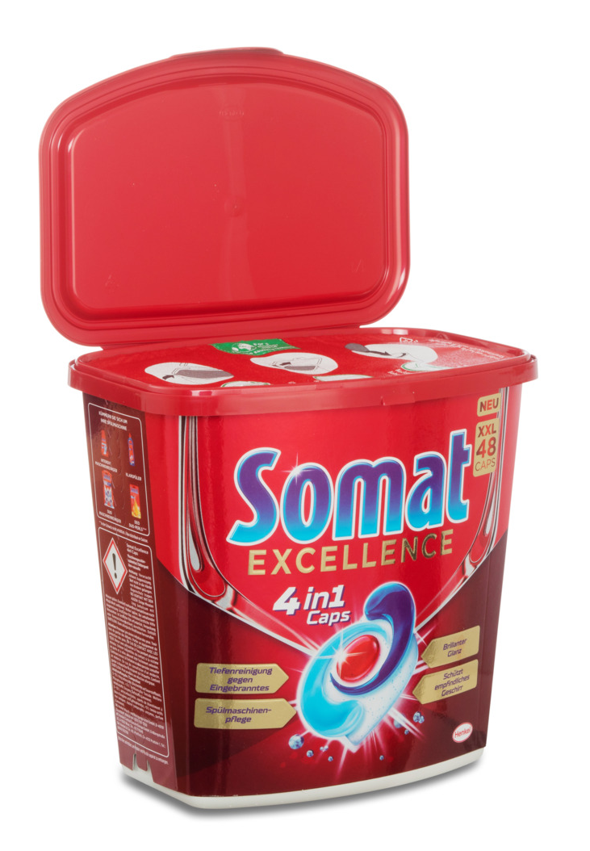
Images for royalty-free use, credit: Greiner Packaging

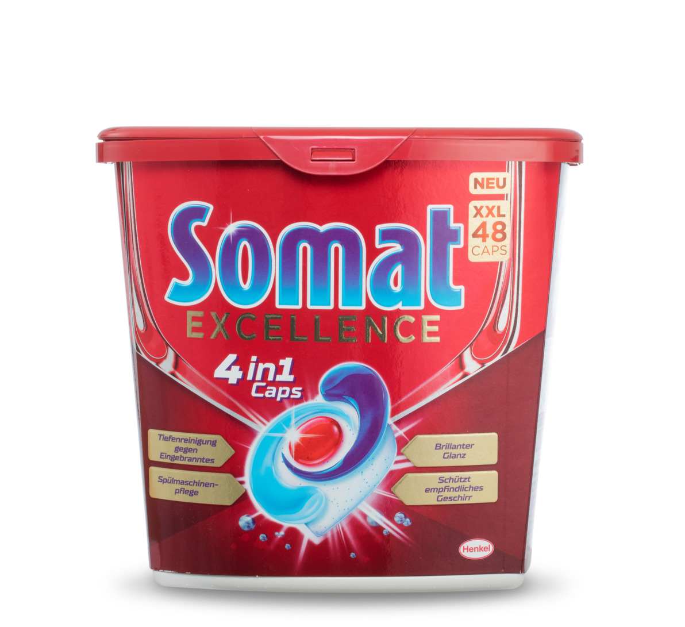
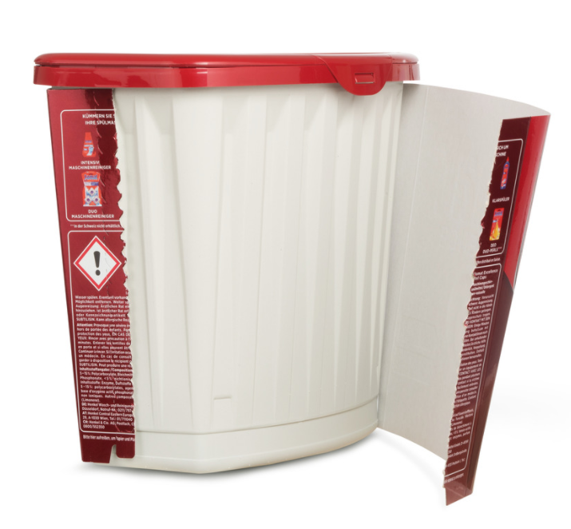

Caption:
Sustainable with a perfect seal: The new dishwasher cap packaging solution produced by Greiner Packaging for Henkel, featuring a tub that contains 50 percent r-PP.

Please direct any questions to:
Roland Kaiblinger I Account Executive
SPS MARKETING GmbH | B 2 Businessclass | Linz, Stuttgart
Jaxstrasse 2–4, 4020 Linz, Austria
Tel. +43 (0) 732 60 50 38-29
E-mail: r.kaiblinger@sps-marketing.com
www.sps-marketing.com/en

