Greiner Packaging develops innovative refill solution that reduces use of plastics
Greiner Packaging is now offering a solution that is as smart as it is environmentally friendly: a sustainable refill bottle that can be used for liquids in spray bottles such as household cleaning products. The bottle can be used for multiple refill doses, doing the work of four conventional spray bottles and trigger sprayers – a supremely simple and affordable way to cut down on plastic waste.
- New, environmentally friendly, 200-ml refill packaging solution for multiple doses of household cleaning products and chemicals
- Takes place of four separate spray bottles and trigger sprayers
- Bottles made from HDPE, PP, or PET material
- Practical fliptop cap with guiding nozzle
- Accurate and consistent dosing and integrated level indicator
- Intelligent refill cycle reduces plastic use by up to 85 percent

Kremsmünster, Austria, March 2021. Refilling is one example of where sustainability starts. Why buy a new spray bottle every time you need household cleaner when there is now an efficient and eco-friendly way to refill your bottle? This was the motivation for Greiner Packaging to team up with its in-house design agency DesPro and develop a new refill concept for plastic spray bottles for household chemicals.

The many benefits of refilling
The newly developed 200-milliliter refill bottle is made of HDPE, PP, or PET material and weighs just around 16 grams in its original form. It contains 200 ml of concentrate, which later produces ten times its liquid volume across four spray bottle refills. Each safe, 50 ml dose can also be adjusted to 30 ml or 40 ml. This is done through a special valve and a guiding nozzle that fits into all standard spray bottles. Thanks to their shape, the new refill bottles make it easy for consumers to squeeze out their contents in consistent doses – plus, they can be provided with an attractive label. In addition, the nonremovable, hinged snap-on lid is fitted with a safety lock. And a user-friendly level indicator completes the list of practical features. As a result, the newly designed bottle is well placed to meet all current market requirements.

Up to 85 percent less plastic used
Greiner Packaging is committed to advancing a sustainable circular economy that, in addition to recycling, also delivers reductions in plastic material use. Consumers can get as much out of a single new refill bottle as they otherwise could from four separate plastic spray bottles, including trigger sprayers – over its lifecycle, original 500 ml spray bottles and trigger sprayers can produce 10,000 individual 1-ml sprays, ensuring that they can be used to its maximum potential. “It goes without saying that we were primarily aiming to reduce material use when we developed the new spray bottle multidose refill. The amount saved increases exponentially throughout the intelligent refill cycle – ultimately yielding a reduction of up to 85 percent. Each year, this could save up to 1,000 metric tons of plastic, if we assume that there are 20 million standard spray bottles a year. In order to be sustainable, reuse of a spray bottle and its refills must become a new normal,” says Tõnu Kundla, International Business Development Manager at Greiner Packaging.

More eye-catching on the store shelf
The new refill bottles developed by Greiner Packaging and DesPro ensure a more eye-catching look at the point of sale than other refill packaging solutions simply because of their size. They also have a large surface area that can be designed or decorated attractively for consumers.
Outer packaging is no longer strictly necessary here, which further reduces material use while underscoring the sustainable approach. The simple, intuitive, and safe dispensing process makes the bottle extremely consumer friendly. And the option of producing the entire bottle from PCR plastic makes this already cost-effective solution even more sustainable.

Maximum flexibility and recyclability
The refill bottle can be made of HDPE, PP, or PET according to the customer’s preference, while the lid can be made from HDPE or PP. Greiner Packaging puts great emphasis on ensuring that the overall packaging is as recyclable as possible. This same approach is consistently applied when it comes to the selection of materials and decorative elements, and the plastics experts consult individually with customers on each project in line with the principles of a circular economy. The valve included in the lid enables the product to be dispensed in an ideal manner with a high degree of precision. This valve part can be mechanically separated later in the recycling process, which increases the recyclability of the packaging solution as a whole. When using labels for decoration, Greiner Packaging recommends that a compatible material is selected to allow for maximum recyclability. This factor comes into play in a number of contexts: when using water-soluble adhesives, when considering the potential effect of the decorative material on the base material used, and – if necessary – when assessing whether the decorative material may be separated from the base material due to the use of different material densities.

Packaging facts:

Bottle:
- Technology: ISBM/EBM
- Decoration: Label possible
- Material: HDPE, PP, PET
Closure:
- Technology: injection molding
- Material: PP/HDPE
- Special features: fliptop cap with guiding nozzle and valve

About Greiner Packaging

Greiner Packaging is a leading European manufacturer of plastic packaging in the food and nonfood sectors. The company has enjoyed a reputation for outstanding solutions expertise in the fields of development, design, production, and decoration for over 60 years. Greiner Packaging responds to the challenges of the market with two business units: Packaging and Assistec. While the Packaging unit stands for innovative packaging solutions, the Assistec unit focuses on producing custom-made technical parts. Greiner Packaging employs a workforce of around 5,000 at more than 30 locations in 19 countries around the world. In 2019, the company generated annual sales revenues of €690 million (including joint ventures), which represents more than 40 percent of Greiner’s total sales.

Text and image:

Text document and high-resolution images for download:
https://mam.greiner.at/pinaccess/showpin.do?pinCode=S5K3wRbW8dLC

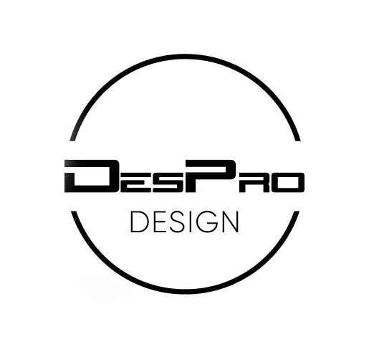
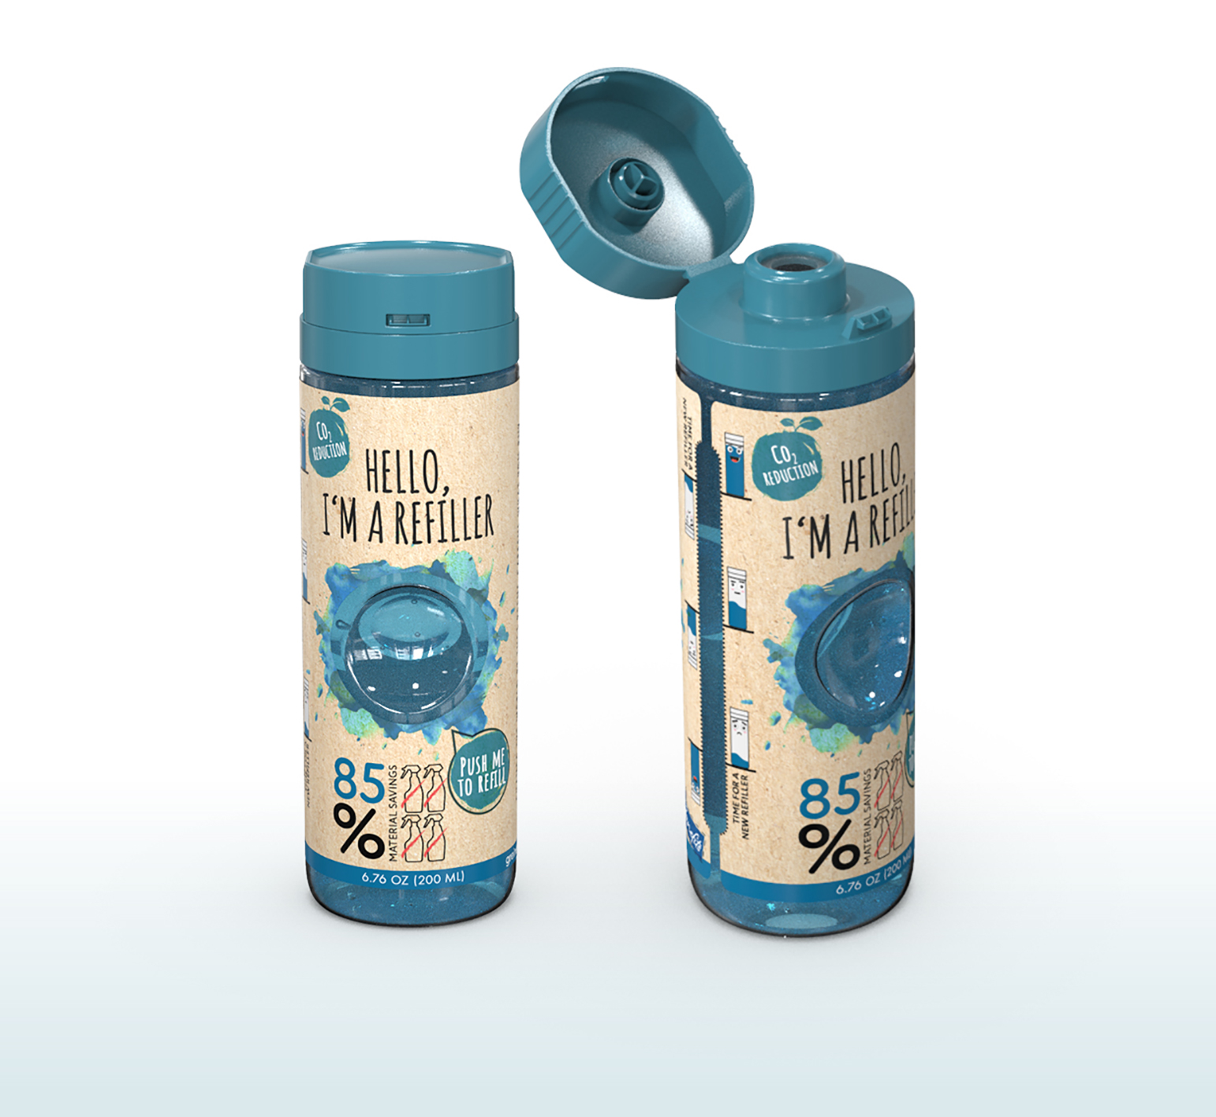

Caption: Thanks to their size alone, multidose refill bottles provide the eye-catching look that is required on the supermarket shelf, even without extra outer packaging. Plus, the bottles can be boldly designed and decorated.

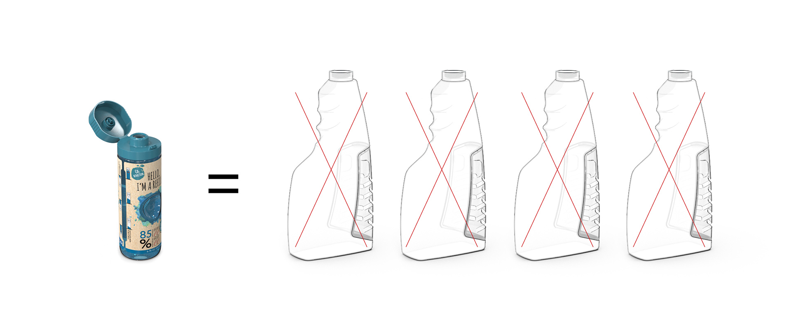
Caption: One equals four: The new multidose refill bottles ultimately reduce plastic use by up to 85 percent via four doses of concentrate.

Please direct any questions to:
Roland Kaiblinger I Account Executive
SPS MARKETING GmbH | B 2 Businessclass | Linz, Stuttgart
Jaxstrasse 2–4, 4020 Linz, Austria
Tel.: +43 (0) 732 60 50 38-29
E-mail: r.kaiblinger@sps-marketing.com
www.sps-marketing.com

