Convenience on the go – now even more eco-friendly:
Greiner Packaging brings new cardboard spoon to market
A spoon included in packaging for convenience products is nothing particularly groundbreaking. But Greiner Packaging and its joint venture partner Cardbox Packaging are now taking this idea to the next level in keeping with the principles of a circular economy. The result is a 100 percent recyclable cardboard spoon.
Kremsmünster, Austria, January 2021. The use of disposable plastic cutlery will be banned in the European Union from mid-2021 – but a perfect alternative is being brought to market in the form of the new fold-out cardboard spoon developed by Greiner Packaging and Cardbox Packaging. Designed for enjoying dairy and snack products away from home, the spoon is right on track with both the convenience and sustainability trends: Consumers want food solutions that are easy to prepare and can also be enjoyed on the go – and they also want the food’s packaging and cutlery to be as user and eco-friendly as possible. Cutlery made of renewable resources such as cardboard, which is 100 percent recyclable in the paper recycling loop, taps into these exact trends.

Smart and sturdy cardboard design
Folded just once, the sturdy cardboard spoon has a length of 10 cm, which gives it the perfect shape and size to conveniently consume dairy products, desserts, fruit, or various types of salad on the go. Thanks to its smart folding style and the innovative shape that resembles a bank card, the spoon is easy to use on the spot. The cardboard spoon is made from virgin fibers and is therefore approved for contact with food, while a water-based coating on the cardboard ensures the spoon can be safely used while eating. But customers can still have branding and a great look with this spoon, too. Custom printing is always available starting at a minimum order quantity. This process naturally uses special food-safe inks and coatings that meet the highest standard for food products.

The completely recyclable alternative
Once used, the folding cardboard spoon can be simply disposed of with other wastepaper. A water-based coating selected for the spoon makes it ideal for recycling in the standard paper recycling stream. Combining it with a top cup made of r-PET and polypropylene (PP) sealing film that can be fully removed from the lid results in a sustainable packaging solution with an excellent recycling profile: To access the spoon, the PP film is automatically separated from the lid. This ensures that the individual packaging components are 100 percent recyclable when correctly disposed of.

A key contribution toward a circular economy
The new cardboard spoon meets Greiner Packaging’s requirements for sustainability perfectly. The plastics experts are committed to the concept of a circular economy that aims to use plastic as sparingly as possible. When the cardboard spoon – which is made of renewable resources itself – needs to be disposed of, it is simply recycled in the paper loop. “We are delighted that more and more partners and customers want to work on sustainable packaging solutions with us. Developing recyclable packaging solutions not only makes sense for the environment but also offers commercial advantages. We are proud to play our part in advancing a circular economy with developments such as the cardboard spoon,” says Konrad Wasserbauer, circular economy director at Greiner Packaging. The cardboard packaging experts at Cardbox Packaging are also proud of the partners’ product innovation: “We were able to pool our expertise as we worked to develop the cardboard spoon, achieving a result that meets consumers’ expectations as well as doing something positive for our environment,” Florian Scharl, managing director at Cardbox Packaging, is pleased to note.

Everything from a single source
An automated process places the cutlery made of cardboard sourced from virgin fibers hygienically packaged in the lids, which are mainly made from r-PET. As such, the cutlery can be perfectly tailored to the needs of the project and the customers, although naturally, the cutlery is also available separately.

Packaging facts:
- Decoration: White or direct printed
- Material: Cardboard made from virgin fibers

About Greiner Packaging

Greiner Packaging is a leading European manufacturer of plastic packaging in the food and nonfood sectors. The company has enjoyed a reputation for outstanding solutions expertise in the fields of development, design, production, and decoration for over 60 years. Greiner Packaging responds to the challenges of the market with two business units: Packaging and Assistec. While the Packaging unit stands for innovative packaging solutions, the Assistec unit focuses on producing custom-made technical parts. Greiner Packaging employs a workforce of around 5,000 at more than 30 locations in 19 countries around the world. In 2019, the company generated annual sales revenues of EUR 690 million (including joint ventures), which represents more than 40 percent of Greiner’s total sales.

About Cardbox Packaging

Cardbox Packaging is an international producer of high-quality and sophisticated cardboard packaging in the luxury and branded goods sector, with a particular emphasis on the food industry. Maintaining the highest quality standards and ensuring customer satisfaction are its top priority. Cardbox Packaging benefits from its lean structure with locations in Austria (Wolfsberg and Pinkafeld), the Czech Republic (Zádveřice), and the United States (Pittston, PA). It is an attractive, expert partner for the European and American markets, particularly in the confectionery, food, cosmetics, and health care sectors.

Text and image:

Text document and high-resolution images for download:
https://mam.greiner.at/pinaccess/showpin.do?pinCode=P5Z4wTmExiiS

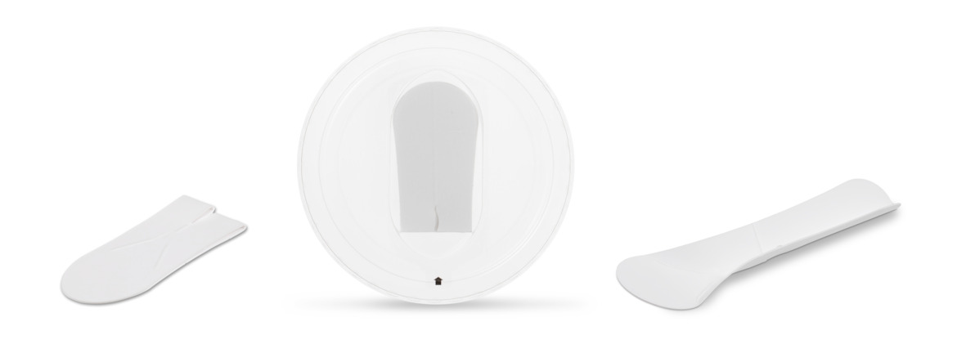

Caption: Smart, convenient, and 100 percent recyclable: The new fold-out spoon from Greiner Packaging and Cardbox Packaging is suitable for any type of dairy product or dessert. Inserted in an r-PET lid, the spoon provides a truly sustainable packaging solution.

Please direct any questions to:
Roland Kaiblinger I Account Executive
SPS MARKETING GmbH | B 2 Businessclass | Linz, Stuttgart
Jaxstrasse 2–4, 4020 Linz, Austria
Tel.: +43 (0) 732 60 50 38-29
E-mail: r.kaiblinger@sps-marketing.com
www.sps-marketing.com/en

