**Greiner Packaging partners with SABIC to create first bouillon packaging made from circular polymer for Unilever**

**These days, plastic packaging manufacturers are faced with ever increasing demands to incorporate more sustainable and more recycled materials, such as r-PP. For the first time, Greiner Packaging has now teamed up with global petrochemical leader SABIC and brand owner Unilever in a pilot project to produce tubs and lids for KnorrTM bouillon powder that are made from 100 percent certified circular PP from postconsumer plastic material. The new solution is already on the market.**

Kremsmünster, Austria, December 2020. Greiner Packaging has already been testing various recycled materials for some time to determine their suitability for the production of its cardboard-plastic combinations. Now, the company has selected certified circular polypropylene from SABIC’s TRUCIRCLE™ portfolio to realize a test project for Unilever. SABIC’s material uses post-consumer mixed plastic as feedstock which is broken down into its molecular building blocks, to create virgin plastics which are then used to produce these new recyclable tubs and lids.

The goal is to produce about 1 million Knorr™ bouillon powder packages for Unilever from 100 percent circular polymer. As the availability of circular polymers will grow in the future, the number of circular tubs will grow alongside. “By producing some of the tubs from certified circular polypropylene, we want to set a new standard on the market together with our partners and demonstrate what is possible with recycled materials in the food segment. We also want to keep pushing forward with this development. Here at Greiner Packaging, we are not only focusing on certified recycled PP – we are also working on our first projects and tests with mechanically recycled PS,” explains Jens Krause, Sales Director at the Swiss Greiner Packaging site in Diepoldsau.

**No compromises in quality & performance**

KnorrTM bouillon powder has now been marketed in the same cardboard-plastic combination for many years. The outer appearance, functionality and safety of the new packaging is exactly the same, and the quality is likewise as high as ever. The difference is that it is made using recycled plastic, making it much more sustainable and environmentally friendly. Nothing has changed from the consumer’s perspective, in other words, and they can still simply remove the cardboard sleeve from the actual tub when the packaging is empty before disposing of the two components as usual. “Our goal is to continue making our packaging more environmentally friendly together with partners like Greiner Packaging and SABIC – especially in the food segment – without consumers having to lower their standards in terms of design, performance, quality, user friendliness, and food safety. We are now testing this using material produced from 100 percent circular polymer, with the goal of expanding across our portfolio by 2025,” says Mike Ross, Senior Packaging Manager at Unilever.

**Advanced recycling: an opportunity for the future**

The certified circular PP polymer from SABIC’s TRUCIRCLE™ portfolio is produced through the feedstock recycling of used and mixed plastic that could otherwise be destined for incineration or landfill. Difficult to recycle used plastic is broken down and taken back to the molecular level by heating it at a high temperature in an oxygen-free environment, producing pyrolysis oil. The pyrolysis oil then enters SABIC’s production chain just like fossil-based feedstock to deliver new materials in compliance with strict quality requirements, such as the hygiene standards for food packaging. The resulting PP polymer is verified and authenticated under the International Sustainability and Carbon Certification (ISCC PLUS) scheme, which uses a mass balance approach. Greiner Packaging sees chemical recycling as an ideal supplement to mechanical recycling.

The new KnorrTM bouillon powder packaging is made from certified circular version of SABIC® FLOWPACT PP impact copolymer that is phthalate-free, safe for food contact while offering robust performance for high stackability and easy processing. The ISCC PLUS accredited material is a drop-in solution for replacing fossil-based plastics in the packaging industry without compromising product purity and food safety.

**K3®-F packaging: the perfect design solution**

KnorrTM bouillon powder comes in K3®-F packaging, which is supplied to Unilever as separate plastic tubs and folded cardboard sleeves. The sleeves are unfolded by a machine and slipped over the tubs directly before filling at the company. This process is especially suitable for global brand manufacturers like Unilever who offer their product in various markets or under different brands and therefore work with a wide range of decoration solutions. This gives them a high degree of flexibility in terms of the design and keeps stocks to a minimum. Plus, the packaging is perfectly stackable, which saves space during transport, as well as making this process more sustainable. The packaging solution is ideal for powdered foods, cereals, pet food as well as various non-food applications. Once empty, the consumer can easily remove the cardboard sleeve and dispose of the two packaging components separately. Alternatively, the resealable and dishwasher-safe tubs can also be used to store foods once the original product has been consumed – either at home or for day-to-day use in the food service industry.

**Packaging facts:**

Technology: Injection molding

Decoration: K3®-F cardboard-plastic combination

Monolayer material: 100 percent certified circular SABIC® FLOWPACT PP impact copolymer

**About Greiner Packaging**

Greiner Packaging is a leading European manufacturer of plastic packaging in the food and nonfood sectors. The company has enjoyed a reputation for outstanding solutions expertise in the fields of development, design, production, and decoration for 60 years. Greiner Packaging responds to the challenges of the market with two business units: Packaging and Assistec. While the Packaging unit focuses on innovative packaging solutions, the Assistec unit is dedicated to producing custom-made technical parts. Greiner Packaging employs a workforce of around 5,000 at more than 30 locations in 19 countries around the world. In 2019, the company generated annual sales revenues of EUR 690 million (including joint ventures), which represents more than 40% of Greiner’s total sales.

For more information please visit: [www.greiner-gpi.com/en](http://www.greiner-gpi.com/en)

|  |
| --- |
| **About Unilever Food Solutions**  We are proud to be part of Unilever, one of the world’s leading suppliers of fast moving consumer goods, with sales in 180 different countries. As the dedicated foodservice business of Unilever, we lead the industry in providing innovative and high quality professional food ingredients and value adding services created by 230 professional chefs. Covering 50 cuisines, in 200 million dishes a day. We outgrow our competition thanks to strong brands such as KNORR, LIPTON and HELLMANN'S, and talented entrepreneurial people working closely with chefs and distributive partners on a daily basis. Unilever Food Solutions is an inspiring global company made up of talented professionals who are always willing to go the extra mile to deliver results for customers. In this positive and open culture, we find inspiration every day, empowering our people to make a 'bigger difference' at every level in the organisation. We provide products and services created by chefs for chefs and aim to do this in a sustainable way.  For more information, please visit [http://www.ufs.com/](https://eur01.safelinks.protection.outlook.com/?url=http%3A%2F%2Fwww.ufs.com%2F&data=04%7C01%7CMike.Ross%40unilever.com%7C7def5d21e50c47cebabf08d88a46aec9%7Cf66fae025d36495bbfe078a6ff9f8e6e%7C1%7C0%7C637411383466639819%7CUnknown%7CTWFpbGZsb3d8eyJWIjoiMC4wLjAwMDAiLCJQIjoiV2luMzIiLCJBTiI6Ik1haWwiLCJXVCI6Mn0%3D%7C1000&sdata=97FqBytrVYk8oB4kl3osD%2B74hA%2B4X5gFhkA9SGM%2BHic%3D&reserved=0) |

|  |
| --- |
| **About SABIC**  SABIC is a global diversified chemicals company, headquartered in Riyadh, Saudi Arabia. SABIC manufactures on a global scale in the Americas, Europe, Middle East and Asia Pacific, making distinctly different kinds of products: chemicals, commodity and high performance plastics, agri-nutrients and metals.  SABIC supports its customers by identifying and developing opportunities in key end-use applications such as construction, medical devices, packaging, agri-nutrients, electrical and electronics, transportation and clean energy. Production in 2019 was 72.6 million metric tons.  SABIC has more than 33,000 employees worldwide and operates in around 50 countries. Fostering innovation and a spirit of ingenuity, SABIC has 12,540 global patent filings, and has significant research resources with innovation hubs in five key geographies – USA, Europe, Middle East, South Asia and North Asia.  For more information, please visit: <https://www.sabic.com/en> |

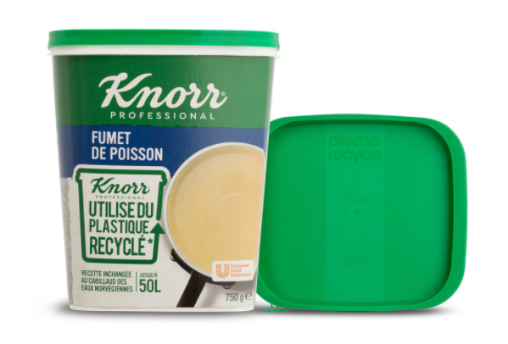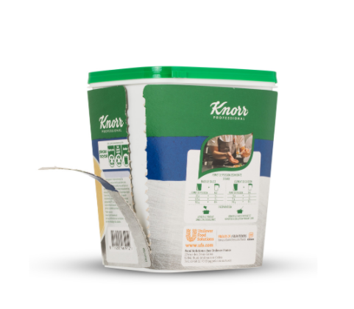

**Text and image:**

**Text document and high-resolution images for download:**

<https://mam.greiner.at/pinaccess/showpin.do?pinCode=z4aSG2m33jQn>

Images for royalty-free use, credit: Greiner Packaging

**Caption:**

The tub and lid for the new K3®-F packaging for KnorrTM bouillon powder have been produced from 100 percent certified circular PP from postconsumer plastic material for the first time.

**Please direct any questions to:**

Roland Kaiblinger I Account Executive

SPS MARKETING GmbH | B 2 Businessclass | Linz, Stuttgart

Jaxstrasse 2–4, 4020 Linz, Austria

Tel. +43 (0) 732 60 50 38-29

E-mail: r.kaiblinger@sps-marketing.com

www.sps-marketing.com/en