Greiner Packaging joins international Alliance to End Plastic Waste

As of today, Greiner Packaging is an official member of the international Alliance to End Plastic Waste. Based in Singapore, the alliance has over 50 member companies, supporters and allies along the entire plastics value chain who aim to use a joint, proactive approach to tackle the problem of plastic waste – especially in cities around the globe.

Kremsmünster, Austria/Singapore, December 1, 2020. In joining the alliance, Greiner Packaging pledges to invest in effective waste management, further the development of the related processes, and integrate them into recycling systems, new technologies, and projects. This approach will, in turn, make it possible to recover resources for a circular economy from plastic waste. The company has already been placing a concerted focus on these efforts for some time and is driving them forward with its own circular economy strategy. As a new member company of the Alliance to End Plastic Waste, Greiner Packaging is now committing to support the alliance by contributing resources, expertise, and investment. The aim of these actions is to promote the topics of infrastructure, innovation, and waste disposal and achieve the partners’ shared vision of cities that are free of plastic waste.

Taking steps to end plastic waste
“Sustainability is central to who we are as a business. Greiner Packaging has been driving innovation in sustainable packaging through initiatives to design for recycling, reduce plastic use, and adopt alternative materials. We are confident that our new partnership with the alliance will help us to bring these efforts to greater heights and make a difference to the future of packaging,” says Manfred Stanek, CEO of Greiner Packaging. As a packaging company, Greiner Packaging is aware of its responsibility toward nature and society. The pollution of cities and oceans is considered one of the greatest challenges we face in terms of preserving the Earth for future generations. With its partners, the company sets ambitious goals and does everything it can to achieve them.

“The alliance welcomes Greiner Packaging into its fold as a member. This addition expands our global footprint and is set to bring us closer to our 2025 vision to divert millions of tons of plastic waste in more than 100 at-risk cities across the globe, improve livelihoods for millions, and contribute to a circular economy,” says Jacob Duer, president and CEO of the Alliance to End Plastic Waste.

About Greiner Packaging
Greiner Packaging is a leading European manufacturer of plastic packaging in the food and nonfood sectors. The company has enjoyed a reputation for outstanding solutions expertise in the fields of development, design, production, and decoration for 60 years. Greiner Packaging responds to the challenges of the market with two business units: Packaging and Assistec. While the Packaging unit focuses on innovative packaging solutions, the Assistec unit is dedicated to producing custom-made technical parts. Greiner Packaging employs a workforce of around 5,000 at more than 30 locations in 19 countries around the world. In 2019, the company generated annual sales revenues of EUR 690 million (including joint ventures), which represents more than 40 percent of Greiner’s total revenue.

About the Alliance to End Plastic Waste
The Alliance to End Plastic Waste is an international non-profit organisation partnering with government, environmental and economic development NGOs and communities around the world to address the challenge to end plastic waste in the environment. Through programmes and partnerships, the Alliance focuses on solutions in four strategic areas: infrastructure, innovation, education and engagement, and clean up. As of November 2020, the Alliance has more than 50 member companies and supporters representing global companies and organisations across the plastic value chain. For more information, visit: https://endplasticwaste.org/.

Text, image & video:

Text document and high-resolution image for download:
https://mam.greiner.at/pinaccess/showpin.do?pinCode=6L70zYI8ZRoe

Image and video for royalty-free use, credit: Greiner Packaging

Video description:
Axel Kühner, CEO Greiner AG, and Manfred Stanek, CEO Greiner Packaging, talk about Greiner Packaging joining the Alliance to End Plastic Waste.

You can find the video here: https://sustainability.greiner.com/en/greiner-packaging-joins-alliance-to-end-plastic-waste/

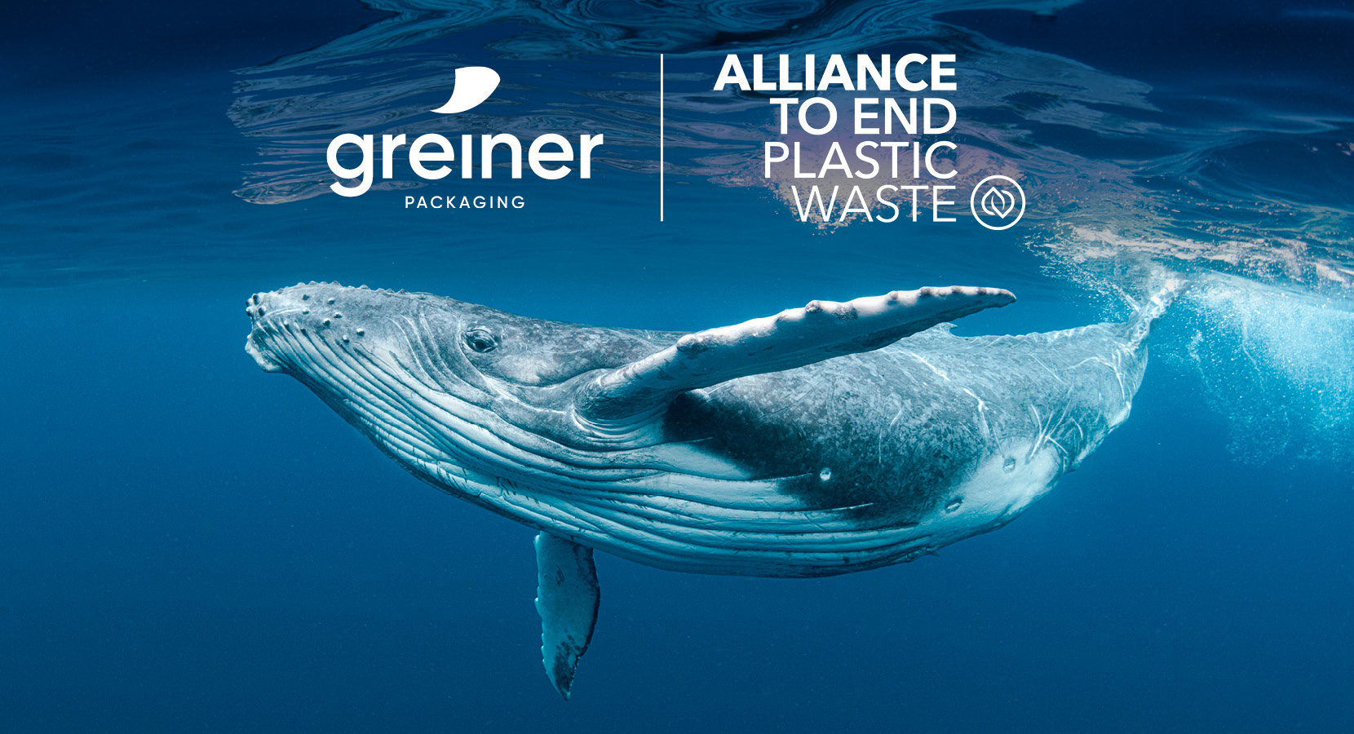
Caption:
The Alliance to End Plastic Waste is an international non-profit organization with currently more than 50 partners. Its aim is to end plastic waste in the environment.

Please direct any questions to:
Roland Kaiblinger I Account Executive
SPS MARKETING GmbH | B 2 Businessclass | Linz, Stuttgart
Jaxstrasse 2–4, 4020 Linz, Austria
+43 (0) 732 60 50 38-29
r.kaiblinger@sps-marketing.com
sps-marketing.com

