Greiner Packaging produces sustainable Pro Nature toilet cleaner bottles for Henkel using 50 % recycled material

Sustainability is a relevant topic, and more and more companies are committed to promoting a circular economy and making a positive environmental contribution with their products. Consumer goods company Henkel pursues ambitious packaging targets – one of the recent examples on its way to further increase the usage of recycled material is a sustainable packaging solution for the toilet cleaner from the Pro Nature product range: the bottle now contains 50% post-consumer recycled polyethylene (r-PE). Greiner Packaging is one of Henkel’s packaging suppliers for this product.

Kremsmünster, Austria, July 2020. The new toilet cleaner bottle stands out not only thanks to its convenience and ease of handling but also because of its sustainable properties: It is composed of 50% post-consumer r-PE. This product represents a valuable contribution to a sustainable circular economy, which both Henkel and Greiner Packaging want to foster. For example, the two project partners have signed the New Plastics Economy Global Commitment launched by the UK-based Ellen MacArthur Foundation. This initiative aims, amongst others, to replace fossil-based virgin plastics with the use of recycled plastics in packaging.

Step by step toward a circular economy
The new Pro Nature toilet cleaner bottle with 50% post-consumer r-PE is just another example of how Henkel and Greiner Packaging are joining forces to demonstrate their commitment to sustainable packaging solutions that foster a circular economy. Last year, the black bottles for toilet cleaner under the Bref brand produced by Greiner Packaging were relaunched in a sustainable version: As black plastic packaging products represented a challenge for the recycling value chain due to the black masterbatch previously used, Henkel teamed up with its supplier Ampacet to introduce an innovative solution for black plastic packaging that is fully recyclable. The new packaging material uses an alternative, carbon-free black coloring agent – thanks to the new masterbatch, the black bottles now can be correctly identified and sorted by optical sensors at waste sorting plants.

Close collaboration for sustainable packaging
“We want to contribute to more sustainable packaging, both with regard to recyclability and an increased use of recycled materials. That’s why we are proud to support our partners like Henkel in implementing their innovative and sustainable projects along every step of the way. A true circular economy can only become a reality if everyone works together,” stresses Michael Frick, Global Key Account Director at Greiner Packaging. Abdullah Khan, who is responsible for Sustainable Packaging Laundry & Home Care at Henkel, is also excited about the partnership: “Henkel and Greiner Packaging have already implemented a number of innovative packaging concepts together. Our new Pro Nature bottle containing 50% recycled material is a shining example of Henkel’s activities to reach our goal to reduce 50% fossil-based virgin plastics by 2025.”

For more information on Henkel’s ProNature product range, please visit www.pro-nature.de.

Packaging facts:
- Material: HDPE, r-HDPE
- Technology: Extrusion blow molding
- Decoration: Sleeve

About Greiner Packaging
Greiner Packaging is a leading European manufacturer of plastic packaging in the food and nonfood sectors. The company has enjoyed a reputation for outstanding solutions expertise in the fields of development, design, production, and decoration for 60 years. Greiner Packaging responds to the challenges of the market with two business units: Packaging and Assistec. While the Packaging unit stands for innovative packaging solutions, the Assistec unit is dedicated to producing custom-made technical parts. Greiner Packaging employs a workforce of around 5,000 at more than 30 locations in 19 countries around the world. In 2019, the company generated annual sales revenues of EUR 690 million (including joint ventures), which represents more than 40 percent of Greiner’s total sales.

About Henkel
Henkel operates globally with a well-balanced and diversified portfolio. The company holds leading positions with its three business units in both industrial and consumer businesses thanks to strong brands, innovations and technologies. Henkel Adhesive Technologies is the global leader in the adhesives market – across all industry segments worldwide. In its Laundry & Home Care and Beauty Care businesses, Henkel holds leading positions in many markets and categories around the world. Founded in 1876, Henkel looks back on more than 140 years of success. In 2019, Henkel reported sales of more than 20 billion euros and adjusted operating profit of more than 3.2 billion euros. Henkel employs more than 52,000 people globally – a passionate and highly diverse team, united by a strong company culture, a common purpose to create sustainable value, and shared values. As a recognized leader in sustainability, Henkel holds top positions in many international indices and rankings. Henkel’s preferred shares are listed in the German stock index DAX. For more information, please visit www.henkel.com
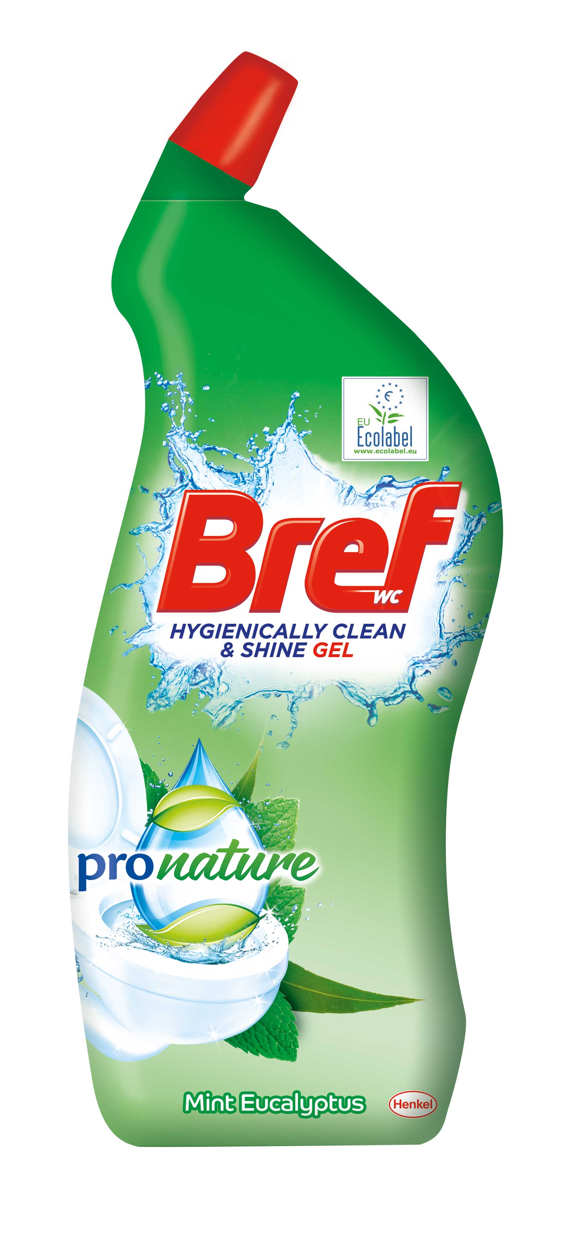

Text and image:

Text document and high-resolution images for download: https://mam.greiner.at/pinaccess/showpin.do?pinCode=OiRFK98h8LGj

Caption: The new Pro Nature toilet cleaner comes in bottles containing 50% recycled polyethylene (PE).

Images for royalty-free use, credit: Henkel

Please direct any questions to:
Mag. Roland Kaiblinger I Text, Design, and PR
SPS MARKETING GmbH | B 2 Businessclass | Linz, Stuttgart
Jaxstrasse 2–4, 4020 Linz, Austria
Tel. +43 (0) 732 60 50 38-29
E-mail: r.kaiblinger@sps-marketing.com
www.sps-marketing.com

