Convenient and sustainable at the same time: Greiner Packaging introduces reusable lid for yogurt cups

Plastic lids provide a secure seal for yogurt after it has been opened – and they extend the shelf life of the food product, prevent it from absorbing odors, and ensure it does not spill. The only problem is that the lids end up in the trash once the yogurt cup is empty. Large volumes of waste are not the only consequence – a valuable resource is also lost forever if no recycling takes place. Together with its long-standing Austrian customer Berglandmilch, Greiner Packaging has now responded to this issue by developing a reusable lid. It is not just convenient but also helps to cut down on the use of plastic.

Kremsmünster, Austria, May 2020. Schärdinger, Tirol Milch, and Stainzer brands have been using the new snap-on lid since April. Manufactured using the injection molding process, the lid is dishwasher-safe and has a 95-millimeter diameter that fits most standard yogurt cups on the market. Because it can be reused, the lid helps save plastic while also sealing the cup perfectly and helping to extend the shelf life of the product inside.

An end-to-end solution with a perfect fit
By producing this reusable lid, Greiner Packaging offers its customers an end-to-end solution – the cup and lid can be manufactured together to ensure a perfect fit. “The reusable lid is environmentally friendly yet convenient – that means we can offer consumers a sustainable solution that’s impressive on a number of levels,” stresses Verena Sallinger, Product Manager at Berglandmilch. “As long-standing partners, we know we can rely on Greiner Packaging. We benefit in terms of both proximity to the production location and security of supply.”

Working together to achieve a circular economy
The reusable lid meets Greiner Packaging’s requirements for sustainability, too – the company is committed to the concept of a circular economy that keeps plastic in circulation as a material for as long as possible. In the event that the lid does have to be disposed of eventually, it will ideally be recycled and incorporated into new plastic products in its reprocessed form. “We’re happy that more and more customers are working together with us on sustainable packaging solutions. This gives us the opportunity to demonstrate that a circular economy in the packaging sector can work when all the stages of the supply chain pull together,” says Konrad Wasserbauer, Director Circular Economy at Greiner Packaging.

Packaging facts:
- Technology: Injection molding
- Decoration: IML
- Material: PP

About Greiner Packaging
Greiner Packaging is a leading European manufacturer of plastic packaging in the food and nonfood sectors. The company has enjoyed a reputation for outstanding solutions expertise in the fields of development, design, production, and decoration for 60 years. Greiner Packaging responds to the challenges of the market with two business units: Packaging and Assistec. While the Packaging unit focuses on innovative packaging solutions, the Assistec unit is dedicated to producing custom-made technical parts. Greiner Packaging employs a workforce of around 4,800 at more than 30 locations in 19 countries around the world. In 2018, the company generated annual sales revenues of EUR 673 million (including joint ventures), which represents more than one third of Greiner’s total revenue.

Text and image:

Text document and high-resolution images for download:

https://mam.greiner.at/pinaccess/showpin.do?pinCode=aiMZHBcW6TAw

Images for royalty-free use, credit: Greiner Packaging

Caption: Convenient and sustainable – the new reusable lid produced by Greiner Packaging and used for brands owned by its customer Berglandmilch.
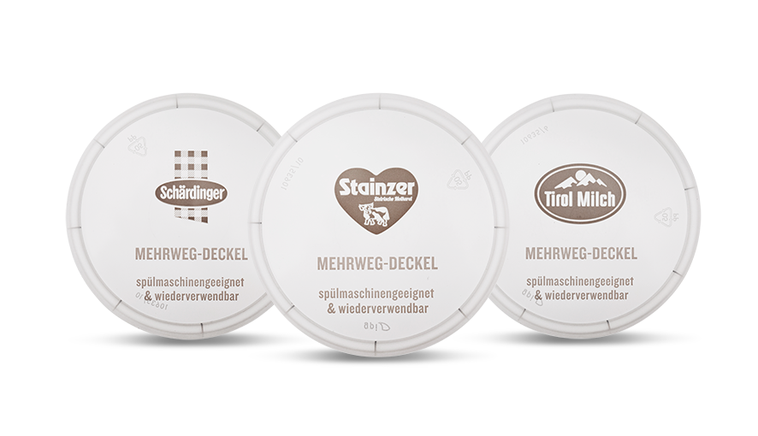

Please direct any questions to:
Mag. Roland Kaiblinger I Text, Design, and PR
SPS MARKETING GmbH | B 2 Businessclass | Linz, Stuttgart
Jaxstrasse 2–4, 4020 Linz, Austria
Tel. +43 (0) 732 60 50 38-29
E-mail: r.kaiblinger@sps-marketing.com
www.sps-marketing.com

