Austrian award for Smart Packaging 2018: Greiner Packaging Receives Special Award for Innovation

In cooperation with Austria’s Federal Ministry for Sustainability and Tourism, the Federal Ministry for Digital and Economic Affairs awards the “Staatspreis Smart Packaging” (National Award for Smart Packaging) every two years. This year, Greiner Packaging took home the Special Award for Innovation for its “fresh clip” solution.

Kremsmünster, November 2018. Good packaging gives brands their distinctive character, influences purchasing decisions, and drives innovation. Austria’s National Award for Smart Packaging recognizes B2B and B2C packaging solutions that stand out thanks to their environmental sustainability and technical functionality as well as their design and convenience. Greiner Packaging’s “Frische-Clip” (fresh clip), which received the Special Award for Innovation in Vienna, impressed the jury in every category.

Preventing food waste
The plastic fresh clip allows the user to reseal a carton after it has been opened. This keeps cereal, muesli, and similar foods fresh for longer, actively helping to prevent food waste. The combination of cardboard and plastic means usage of both materials is reduced to a minimum. At the same time, the solution ensures that the contents are given optimum protection against moisture, pests, and spoilage.

An eye-catching solution using less plastic
The fresh clip is produced using the injection molding process. It features a sealing surface onto which a plate element made of plastic, cardboard, or aluminum can be affixed – this ensures the package’s original appearance on retail shelves and enables the clip function once it has been removed. The creases positioned around the clip allow the packaging to be clipped together and sealed. The fresh clip can be attached to the carton in such a way that it can either be removed or remain affixed. There is the option to attach the clip permanently with adhesives, and interlocking or mechanical connections could be integrated as well. Reducing the plastic content was central to the clip’s design. A variety of finishing methods – from gloss, matte, and metallic to textures and tactile elements – can be used to attract more attention at the point of sale. A clicking sound signals that the clip is completely sealed.

Ease of use
But the packaging isn’t just visually appealing; it’s also easy to use. The contents of the carton can be accessed by simply pulling off the plate element. To seal the packaging again, the two grips on the sides are pressed together until the clicking sound is heard. The packaging’s gape-like opening is also an aid to dispensing and pouring out the contents.

The award ceremony took place at “Österreichischer Verpackungstag” in Vienna, an event focusing on Austria’s packaging industry. More than 60 entries in five categories were submitted for the award this year.

About Greiner Packaging
Greiner Packaging is a leading European manufacturer of plastic packaging in the food and non-food sector. For almost 60 years, the company has stood for a high level of solutions expertise in the fields of development, design, production, and decoration. Greiner Packaging addresses the challenges of the market with two business units: Packaging and Assistec. Greiner Packaging employs a workforce of around 4,800 at more than 30 locations in 19 countries worldwide. In 2017, the company achieved annual sales revenues of EUR 641 million (including joint ventures). This represents more than one third of Greiner’s total revenue.

Text and image:

Text document and high-resolution images for download:
https://mam.greiner.at/pinaccess/showpin.do?pinCode=rhiT9byJnFAJ

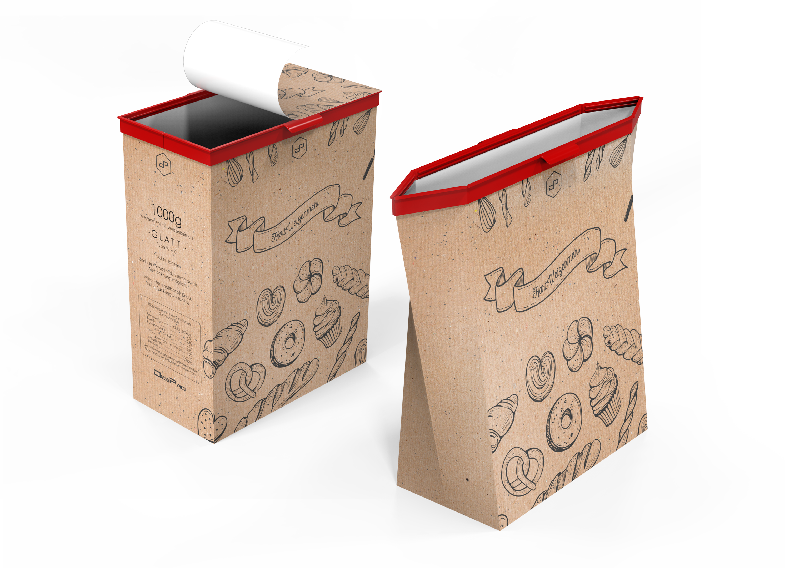
Image 1 for use free of charge, credit: Greiner Packaging International

Image text 1: The fresh clip from Greiner Packaging combines an attractive design with sustainability and convenience. Thanks to these features, the clip received the Special Award for Innovation at the ceremony for the Austrian National Award 2018.

Image 2 for use free of charge, credit: Matthias Silveri

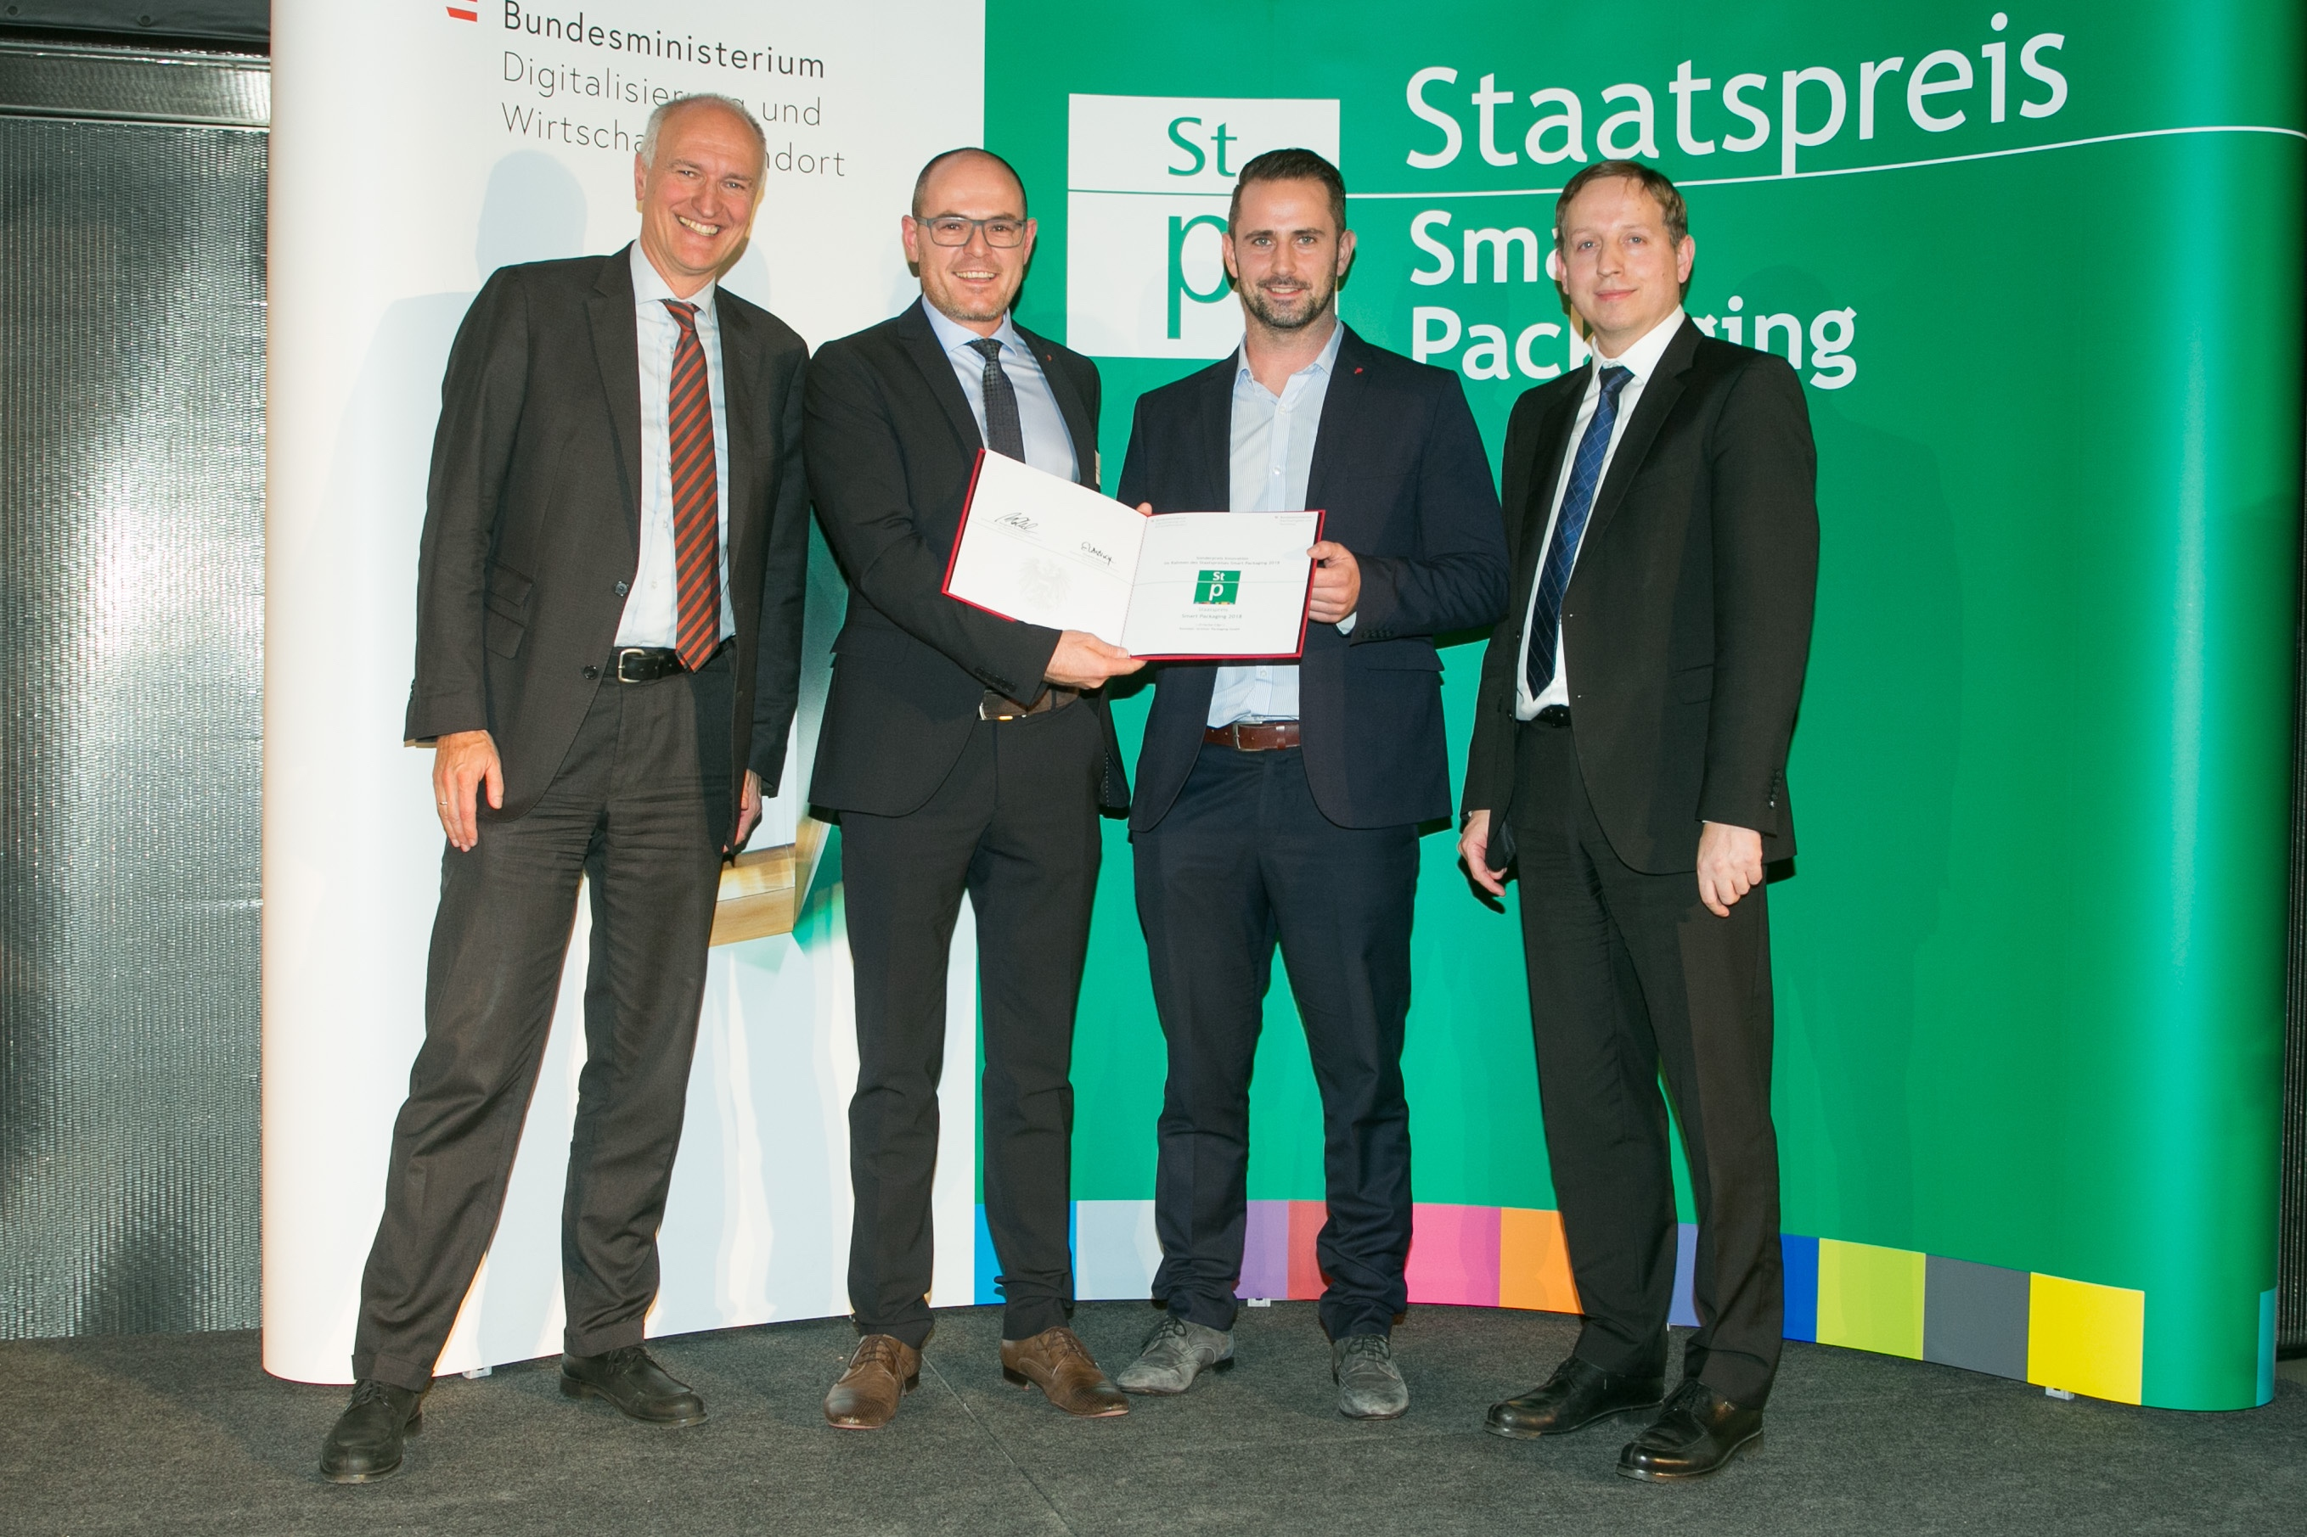

Image text 2: Stefan Ebli and Martin Weingartmair from the DesPro (Design & Prototyping) department at the presentation of the award to Greiner Packaging.
Persons from left to right: Section Manager Mag. DI DDr. Reinhard Mang, Mr. Stefan Ebli, Mr. Martin Weingartmair, Secretary General Dipl.-Ing. Michael Esterl

If you have any queries, please contact:
Ms. Carina Maurer I Text, Design, and PR
SPS MARKETING GmbH | B 2 Businessclass | Linz, Stuttgart
Jaxstrasse 2–4, 4020 Linz, Austria
Phone: +43 (0) 732 60 50 38-29
E-mail: c.maurer@sps-marketing.com
www.sps-marketing.com

