Greiner Packaging extends its range of recycling materials

The use of recycled material is playing an increasingly important role in the work of Greiner Packaging. The new circular economy strategy, which the plastic packaging manufacturer has been actively pursuing since the autumn, involves adopting a holistic approach. This includes making savings in material and CO₂, as well as increasing the recyclability of its packaging and the use of greater quantities of recycled material such as r-PET, r-PP and r-PS.

Kremsmünster, November 2020. Greiner Packaging has been using recycled materials such as r-PET and r-PP in the production of its plastic packaging for some time. However, this does not involve the use of a preferred material, but rather developing a sustainable material solution that is perfectly tailored to the needs of the customer. While PP and PS are by far the most commonly used materials in the dairy packaging industry, some of the recyclates from both materials still lack approval for use in food packaging and have only limited availability.

This is where r-PET comes into play. It is readily available through existing bottle recycling streams, but has so far been largely unsuitable for dairy packaging due to its material properties. Where high temperature sterilization (HTS) is required, PET has to withstand temperatures of up to 120°C. With initial tests for the use of r-PET HTS in packaging for dairy products, Greiner Packaging is expanding its material competence and adding another component. At the moment, r-PET is the only food-approved recycled material, while r-PS and r-PP are still in the test and approval phase. It is therefore important to provide dairies with a recycled material that can withstand the necessary production processes. For Greiner Packaging, Crystalline-PET (CPET) does not represent a solution for the dairy market. It can withstand hot sterilization of up to 240°C. The disadvantage, however, is that the nucleating agents contained in it make recycling difficult. Closed loops are therefore difficult to achieve.

Mechanically versus chemically recycled material
A distinction is generally made between mechanical and chemical recycling of r-materials. The former has a better carbon footprint, while the latter enables dirty yet valuable material or composite material to be recyclable. Although the chemical process is a little more complicated, the quality of the product is comparable to virgin material which means that approval for its use in food packaging is assured. Experts believe that chemically recycled material will soon be officially recognised as recycled material.

First high-temperature solutions for r-PET packaging for dairy products now in sight
Mechanically recycled PET is available in relatively large quantities from the material cycle which means that new plastic products can easily be manufactured from up to 100% mechanically recycled PET for use in the food industry. Tests are currently underway for the dairy industry to see how PET can tolerate temperatures of up to 120ºC during high-temperature sterilisation (HTS). The main focus will be on how the current sterilisation process can be compatible with H₂O₂. The aim is to ensure that dairies are not forced to make changes to the filling process when using recycling material such as r-PET. Greiner Packaging is working hard to find a solution in consultation with its dairy customers and the results are keenly awaited.
“We are also in the process of finding an alternative to the PET bottle stream. Obtaining recycled material from different sources would mean us no longer being solely dependent on bottle flakes in the medium and long term. We are currently evaluating different sources and opportunities, as well as having discussions with a number of suppliers who can offer social PET. One example is our work with Plastic Bank,” explains Jörg Sabo, Global Marketing and Innovation Director at Greiner Packaging.

r-PP currently only approved for use in the non-food industry
Mechanically recycled PP (polypropylene) can currently only be used for non-food packaging, however a food approval is in preparation. Chemically recycled PP is suitable for food contact, but not readily available as there are no large-scale recycling streams for PP. Greiner Packaging is currently involved in a project that aims to obtain food approval for r-PP from mechanical recycling.
Initial test series with r-PS yogurt containers in Switzerland
Recycled polystyrene (r-PS) is in very short supply as a chemically and mechanically recycled material. Here too, recycling streams must first be established. However, earlier tests have already proved that the high purity content of PS makes it ideally suited to mechanical recycling. Initial tests in Switzerland have shown that Greiner Packaging is already capable of producing yogurt containers made from 100% r-PS material. 100% mechanically recycled PS was used with 100% recycled cardboard for the first time in a joint project with M-Industry. The whole process was tested for typical Swiss K3® twin yogurt packs. The results were promising. None of those involved in the test noticed any sensory deviation as a result of the new, first-time use of r-PS material. The process for obtaining certification of r-PS for use in yogurt containers is already underway in Switzerland.

A greater range of material for a sustainable future
Greiner Packaging is currently heavily involved in work on the use of r-PET, r-PP and r-PS in the food industry, with a view to utilising greater quantities of recycled material in the manufacture of its plastic products in future. A holistic approach, together with the search for different material options, should lead to quick results, irrespective of whether an issue relates to new material-specific process innovations or particular food approvals.

About Greiner Packaging
Greiner Packaging is one of the leading European plastic packaging manufacturers in the food and non-food sector. For 60 years, the company’s name has been synonymous with outstanding expertise in providing solutions in the areas of development, design, production and decoration. Greiner Packaging conducts its business through two operational units, Packaging and Assistec. The former is known for its innovative packaging solutions, while the latter focuses on the production of customised technical components. The company employs around 5,000 staff at more than 30 locations in 19 countries worldwide. Its turnover in 2019 was €690 million (including joint projects), representing more than 40% of Greiner’s total revenue.

Text and image

Text document and high-resolution quality images to be downloaded
https://mam.greiner.at/pinaccess/showpin.do?pinCode=xL7jc5Aj7oti

Royalty-free images. Credit: Greiner Packaging

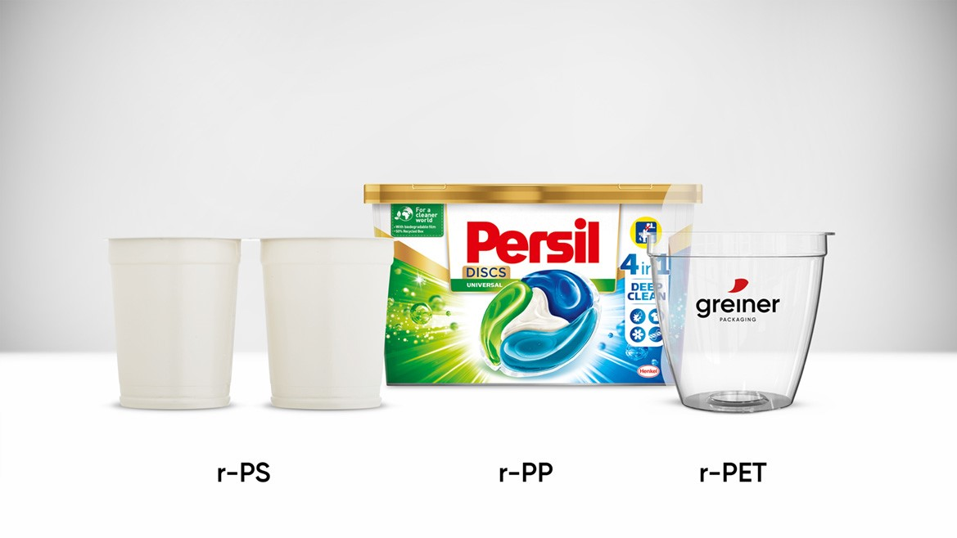

Picture caption
Greiner Packaging is already manufacturing products made from r-PS, r-PP and r-PET. The use of high-temperature resistant r-PET material is currently being tested and would represent a further milestone in the development of sustainable packaging.

For further information, please contact:
Roland Kaiblinger I Account Executive
SPS MARKETING GmbH | B 2 Businessclass | Linz, Stuttgart
Jaxstraße 2 – 4, A-4020 Linz,
+43 (0) 732 60 50 38-29
r.kaiblinger@sps-marketing.com
sps-marketing.com

